Prof. P.A. Ramakrishna
Department of Aerospace Engineering
Indian Institute of Technology Madras
Chennai – 600 036, India
PROJECT COORDINATOR
Ref: No. ASE/PARA/ BOD / MUAY / 2017/ DATE: 26.09.2017

Due date : 13.10.2017

Dear Sir,

- Quotations are invited in duplicate for the various items shown below/overleaf/enclosed list.
- The quotations are to be in two parts as:
Technical Offer and as Commercial offer
The two parts of the offer are to be clearly marked on the envelopes. The two parts of the offer in separate envelopes must be enclosed in the one bigger envelope duly sealed and super scribed with reference number and due date and must be addressed to the undersigned so as to reach him on or before the due date stipulated above.
- The quotations duly sealed and super scribed on the envelope with reference no. and due date, should be addressed to the undersigned so as to reach him or before the due date stipulated above.
- Quotations should be valid for 60 days from the due date and period of delivery be indicated.
- Local firms to quote for free delivery to this Institute. If quoted for Ex-Godown delivery charges are indicated separately.
- Relevant literature pertaining to the items quoted with full specifications.
- Sales Tax/General Taxes/ED if applicable and such other taxes legally legible and intended to be claimed should be distinctly shown along with the price quoted. If this is not indicated no such claim will be admitted at any stage. The taxes legible should take into consideration that we are entitled to have concessional Sales Tax applicable to Non-Government Educational Institutions run with no profit motive for which a concession is given. Sales Tax Certificate will be issued at the time of final settlement of the bill.
- Goods should be supplied carriage paid and insured.
- Goods shall not be supplied without an official supply order.
- Every effort will be made to make payment within 30 days from the date of bill/acceptance of goods whichever is later.
- The Guarantee period of the item may be indicated clearly.
- In case of LC. Payment 90% of the payment will be made after completion of the supply. The balance 10% of the payment will be made after satisfactory installation of the equipment.
- IIT Madras is exempt from payment of Excise Duty and is eligible for concessional rate of custom duty. Necessary certificate will be issued on demand. IIT Madras will make necessary arrangements for the clearance of imported goods at the Airport/Seaport. Hence the price should not include the above charges.
- Acceptance and Rejection- I.I.T. Madras has the right to accept the whole or any part of the Tender or portion of the quantity offered or rejects it in full without assigning any reason.
- Fax and Email quotations are not acceptable.

Yours faithfully

-sd-

Project coordinator

Items required: Forced air circulation based BIOCHEMICAL OXYGEN DEMAND (BOD) INCUBATOR (1 Nos.) as per specifications enclosed
------------------------------------------------------------------------------------------------------------------
Phone Nos.: (044) 2257 5000 / 5018 / 4018 FAX: (044) 2257 4002, E-mail: parama@iitm.ac.in

Department of Aerospace Engineering
Indian Institute of Technology Madras
Chennai – 600 036, India

Specifications of the BOD incubator (1 Nos.):

S. No. | Item/specification | Range/Type/Description
1. | Ambient condition | 0-50 ⁰C
2. | Operating/producible/achievable temperature range in BOD incubator | 0 ⁰C to +75 ⁰C
3. | Temperature sensitivity | +/- 0.1 ⁰C
4. | Temperature uniformity | +/- 1 ⁰C
5. | Temperature control using PID or equivalent control device | Programmable:  - Profile with different ramp up, ramp down and soak features  - Profile containing >= 8 feed points  - Cycling feature for any number of times
6. | Data acquisition port  PC/laptop communication port | Yes. To feed temperature cycles and record time vs. temperature data from BOD sensors
7. | Independent overheat and overcool protectors with buzzer alarms | 2 Nos. in parallel – for overheating  2 Nos. in parallel – for overcooling
8. | Maximum heating rate | 5 ⁰C per minute
9. | Minimum heating rate | 2 ⁰C per hour
10. | Maximum cooling rate | 5 ⁰C per minute
11. | Minimum cooling rate | 2 ⁰C per hour
12. | Air circulation | Forced type, minimum 2 fans
13. | Withstand continuous operation >six months | Yes
14. | Inner chamber volume | Minimum 2 cubic feet with 4 shelves
15. | Inner chamber wall | Stainless steel, appropriately insulated
16. | BOD outer wall | Rust, corrosion proof
17. | Lock and buzzer alarm for door | Yes
18. | Calibration and operating manual | Yes
19. | Supply voltage and frequency | ~220 V and 50 Hz
20. | CFC free refrigeration system | Yes
21. | Performed and complied with the attached three tests (see page 4-5) | Yes

Note: Please see next page for the additional requirements.

Department of Aerospace Engineering
Indian Institute of Technology Madras
Chennai – 600 036, India

Additional Requirements:
- Vendors should provide continuous technical support and maintenance of equipment.
- If the waiting period for repair during warranty exceeds more than 15 days then the warranty period shall be extended by the amount of days taken for repair.
- Vendors have to provide warranty for a minimum of one year. Cost of annual system support/ maintenance contract once the warranty period is over has to be quoted for a period covering 5 years from the date of purchase. Payment for the AMC will be made only at the end of warranty period on yearly basis.
- Vendors must have sufficient experience in supplying equipment in reputed organizations for research purpose. They must provide references of end users whom we can contact for their opinion.
- Vendors must provide detailed documentation for the equipment, including calibration certificate, design certificate.
- Vendors may be called to visit and give presentation/demonstration on the equipment after opening the technical bid. They need to provide the approximate date for this presentation in the bid. The time period for this presentation would be 14 days from the date of opening of the bid.
- Vendors must provide training to our technical staff for using the equipment.
- All the expenses for installation, training and post sales technical support will be borne by the vendor.

Note: Please see next page for the mentioned tests.

Department of Aerospace Engineering
Indian Institute of Technology Madras
Chennai – 600 036, India

Test-1

This test has five steps. Graphical feed profile is also attached.
- Ambient (say 35 deg C) to 10 deg C in 20 min
- 10 deg C to 60 deg in 10 min (ramp up)
- Maintain at 60 deg for 5 min (soak/dwell time)
- 60 deg C to 50 deg C in 5 min (ramp down)
- 50 deg C to 2 deg C in 10 min (ramp down). If minimum achievable temperature is +5 deg C then ramp down to 5 deg C in 9 min
- 2 deg C to 25 deg C in 10 min (ramp up)
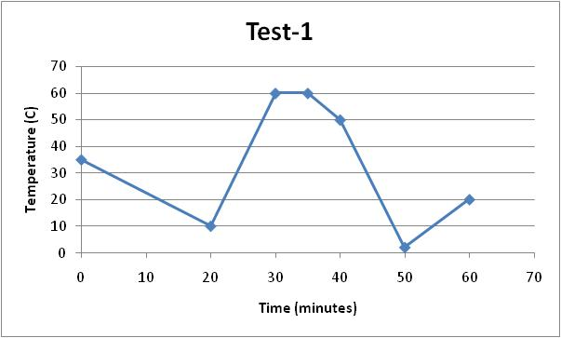
Test-2

This test has seven steps and it takes longer time to complete. But it should not be a problem with PC interfaced BOD. Graphical feed profile is also attached.
- Ambient (say 35 deg C) to 33 deg C in 0.5 hr
- 33 deg C to 34 deg C in 0.5 hr (ramp up)
- 34 deg C to 42 deg C in 0.5 hr (ramp up)
- 42 deg C to 41 deg C in 0.5 hr (ramp down)
- 41 deg C to 22 deg C in 1 hr (ramp down)
- 22 deg C to 23 deg C in 0.5 hr (ramp up)
- 23 deg C to 22 deg C in 0.5 hr (ramp down)
- 22 deg C to 21 deg C in 1.5 hr (ramp down)
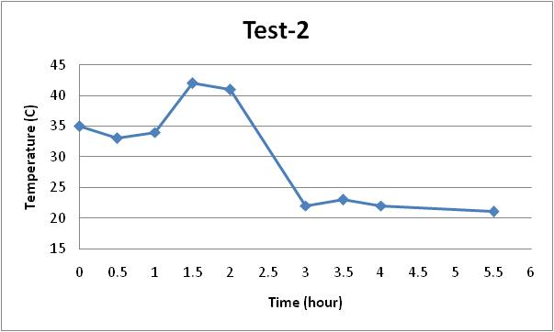
Test-3
This test verifies profile cyclic feature of the BOD. The given profile is needed to be cycled for 3 times (for example). Graphical profile is also shown.

