Ref. No. Copt/ASE/1718/143/DRDO/SRCH/003 Date: 16 Nov. 2017
Due date: 06Dec. 2017
Item name: SUPPLY AND INSTALLATION OF REAL TIME INSTRUMENTATION SYSTEM AND LabVIEW BASED DAQ SOFTWARE FOR MICROGRAVITY DROP FACILITY.
- Quotations are invited in a two bid system for the items shown overleaf (in Annexure I). The offers / bids should be submitted as Technical bid and Financial bid separately. The Technical bid should consist of all technical details / specifications only. The Financial bid should indicate item-wise price for each item and it should contain all Commercial Terms and Conditions including Taxes, transportation, packing & forwarding, installation, guarantee, payment terms, pricing terms etc. The Technical bid and Financial bid should be put in separate covers and sealed. Both the sealed covers should be put in a bigger cover. The Tender for supply of “__________________” should be written on the left side of the Outer bigger cover and sealed.
- The quotations should be valid for sixty days from the due date and the period of delivery required should also be clearly indicated.
- The total cost of the equipment in terms of CIP Chennai should be clearly mentioned.
- Terms of warranty and guarantee should be explicitly mentioned.
- Packing and delivery charges, customs and clearance duty should be clearly stated.
- Goods shall not be supplied without an official supply order.
- Local firms : Quotations should be for free delivery to this institute. If quotations for ex-godown delivery charges should be indicated separately.
- Firms outside Chennai: Quotations should be for F.O.R. Chennai. If F.O.R. consignor station, freight charges by passenger train / lorry transport must be indicated. If ex-godown, packing, forwarding and freight charges must be indicated.
- The rate of sales / general taxes and the percentage of such other taxes legally leviable and intended to be claimed should be distinctly shown along with the price quoted. Where this is not done, no claim for sales / general taxes will be admitted at any stage and on any ground whatsoever. The taxes leviable should take into consideration that we are entitled to have Concessional Sales Tax (CST) applicable to non-government educational institutions run with no profit motive for which a concession sales tax certificate will be issued at the time of final settlement of the bill.
- Payment : Specify the mode of payment and if advanced payment has to be made. Every attempt will be made to make payment within 30 days from the date of receipt of bill / acceptance of goods, whichever is later.
- IIT Madras is exempt from payment of excise duty and is eligible for concessional rate of customs duty. Necessary certificate will be issued on demand.
- IIT Madras has the right to accept the whole or any part of the tender or portion of the quantity offered or reject it in full without assigning any reason.

- The sealed quotation may be sent to
The Purchase Manager,
CoPT OFFICE, NCCRD Building
Behind Aerospace Engineering Dept., IIT Madras
Chennai – 600036, Ph. (O) +91-44-22579863

ANNEXURE 1
Ref. No. Copt/ASE/1718/143/DRDO/SRCH/003 Date: 16 Nov. 2017
Due date: 06Dec. 2017

Supply and Installation of Real time instrumentation system and LabVIEW based DAQ software for Microgravity Drop facility

A real time instrumentation system with data acquisition software are to be provided for controlling and sequencing the operations inside microgravity drop facility of IIT Madras. The experiments are conducted in a drop capsule which is dropped from a 38 m drop tower. The controlling of the experiments and the drop sequence are to be done from the first floor laboratory. A wireless communication system has to be arranged to facilitate the control operations of the capsule till the drop and a separate shock resistant wireless system is required on the falling capsule for controlling the experiment parameters, recording the data, storing it onboard as well as transmitting the data to the remote computer at the ground station. The requirements with a detailed description with necessary diagrams are provided in the sections below. The vendors are advised to thoroughly go through the document and discuss with the concerned to have a better understanding.
- Microgravity Drop Tower
A short description of the experimental facility is as follows. Microgravity drop tower is a facility that allows experiments to be setup in a state of free fall for a short duration. The experiments are conducted in cylindrical enclosures called capsules which are dropped from a 38 m drop tower and the drop sequences are controlled from the first floor laboratory. The drop capsule consists of an inner and an outer capsule. The inner capsule, 60 cm diameter and around 125 cm tall container, houses the experiment chamber and support instrumentation. The inner capsule is housed inside the outer capsule, 80 cm diameter and 250 cm tall, which acts as an aerodynamic shield during the fall of the capsule. The data acquisition system is located inside the inner capsule. THERE IS NO PHYSICAL CONNECTION BETWEEN THE INNER CAPSULE AND THE OUTER CAPSULE DURING THE DROP. Finally the falling capsule is recovered safely by decelerating it using a deflating airbag system which facilitates controlled airflow through two knife edge gate valves.
Experiment data is obtained from the drop capsule using onboard data acquisition system. This data has to be transferred to the user computer at the ground station (first floor level laboratory). A real time data telemetry unit should be used, that can withstand high shock loads. The images and videos from the high-g camera is stored onboard and transmitted to the ground station. The camera needs a trigger voltage of 5V. The tele-command line has to be kept alive during the drop experiment with basic commands that can be routed to individual controls within the experiment. For releasing the drop capsule, a separate telemetry unit is already set up. For preventing any accidental release, a safety mechanism is also implemented. The data acquisition from the experiment module has to be synchronized with the operations of the release mechanism and safety mechanism. These units are permanently fixed to the hoisting platform and hence will not be under free fall during the experiment.

- Communication System
A combination of wired and wireless communication system is to be designed to facilitate the control operations of the capsule till the drop, setting parameters inside the experiment chamber, recording the data, storing it onboard as well as transmitting the data to the host computer at the ground station. The whole unit is split into four major modules – Ground station module (GROUND), Release module (REL), Safety latch module (SAF) and experiment module (EXP). This is explained in figure no. 1. The EXP module consists of the capsule control system, which forms the control manager for various operations within the inner capsule. The GROUND station communicates with the Capsule Control System (CCS) through electrical signals sent via wired networks and radio signals through Wi-Fi modems.
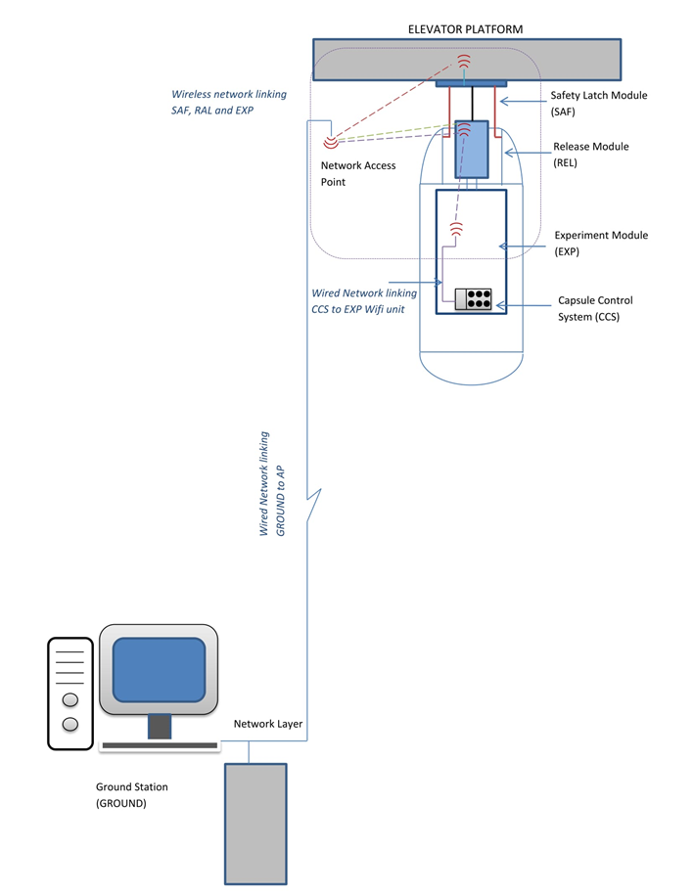
Figure 1: Schematic of the drop tower communication system
- System Requirements

  - Necessary units
The Data Acquisition (DAQ) units along with the sensors and basic requisite accessories are already purchased. The LabVIEW based DAQ software and the additional sensors required should be compatible with the following units. The units are already purchased or will be available at the time of installation; except for the wireless access points, battery and the laser distance sensor.
Details of necessary units :
Sl. No: | Units | Quantity | Specifications/Descriptions
 | DAQ Modules
1 | cRIO 9067 | 1 | NI Compact RIO Control Chassis
2 | cDAQ 9171 |  | NI Compact DAQ USB Chassis
3 | NI 9234 | 1 | 4 channel Analog Input Module for Accelerometer
4 | NI 9401 | 1 | Digital I/O Module
5 | NI 9220 | 2 | Analog Input for voltage-pressure transducer
6 | NI 9505 | 1 | DC Brushed Servo Motor Drive With Encoder
7 | NI 9481 | 1 | 2+ Relay module SPST
8 | NI 9211 | 1 | Thermocouple Input Module
9 | NI 9229 | 1 | 4 channel Analog Input Module
10 | NI 9213 | 1 | 16 channel Thermocouple Analog Input Module
11 | NI 9264 | 1 | 16 channel Analog Output Module
12 | NI 9375 | 1 | 16 channel DI/DO Module
 | Sensors
13 | MEAS 4610A | 1 | Single Axis Accelerometer
14 | Laser Distance Sensor | 1 | Analog Output Proximity Type, 0 – 45 cm or better, resolution < 1.75 mm or better (to be purchased by the vendor)
15 | Mass Flow Controller | 3 | Specifications will be shared later
16 | Thermocouples | 8 | 8 channels required.
17 | Pressure transducer | 1 | Strain gauge based transducer
 | Camera
18 | High g Camera | 1 | IDT NX3S4
 | Access Point
19 | Wireless Access Point | 1 | Rugged unit, Moxa make (to be purchased by the vendor)
 |  | 2 | D-link make or Netgear make(to be purchased by the vendor)
 | Host PC (Computer)
20 | System Specifications | 1 | HP Z230 Tower Workstation, Processor – Intel(R) Xeon(R) CPU E3-1226 v3@ 3.30 GHz, 16348 MB RAM, NVIDIA Quadro K620, OS – Windows 7 Professional 64 bit
DC Power Supply
21 | Battery for Experiment module | 1 | Two 24 V or more, 5 Ah or more each. High g resistant (to be purchased by the vendor)

Note:
- Distribution/Terminal locks, Switch-Battery charge/discharge control, Connector for Battery- Charger and Electrical accessories required for the integration of the specified hardware must be provided by the vendor.
- A 10 Ah or more, 24 V battery can be provided in lieu of the 5 Ah batteries.

  - Capsule Control System (CCS) Requirements

- The system will carry out the automated execution of the drop sequence during the experiment and perform data acquisition from different sensors.
- The system will stream data wirelessly from the experiment module to the host PC located in the ground station, where the data will be recorded.
- The data acquisition and control will be implemented using National Instruments’ CompactRIO platform. There will be Analog I/O and Digital I/O modules to interface different subsystems.
- The system will be powered by a rechargeable battery with suitable regulators. The battery will power the Compact RIO, Sensors, Mass Flow controllers, Fan, Heater circuit and the high-speed digital camera.
- Since the experiment duration is less than 3 s, the maximum performance parameters for a short duration operation has to be provided.
A block diagram of the data acquisition in cRIO and overall communication architecture is given in the figure.
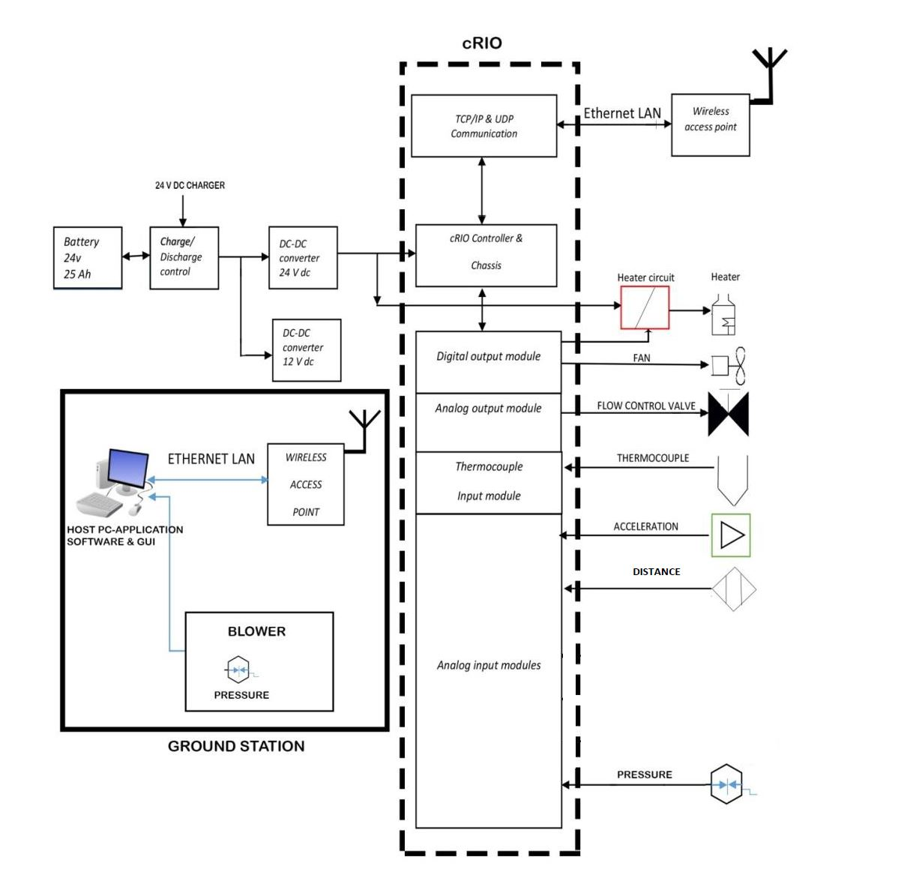
SOLENOID VALVES OF THE GATE VALVE SYSTEM
Figure 2: Block diagram of the Capsule Control System
  - Application Software Requirements

- The application software will provide the GUI for operating the Microgravity tower facility.
- It should have features for the control and data acquisition of Release Module, Safety Module and Experiment Module.

Functionalities:

- User access control: The application software should have features to login and access the system for authorized users.
- System Hardware configuration: The software should have panel to configure the I/O interface modules, depending on the sensors and instruments connected to it. The panel will also feature calibration options for the channels.
- Modes of Operation: The DAQ software should have two modes of operation viz. acquire mode and record mode.
- Acquire mode: This is a view data mode [Refer sequence 1 in figure 3]. This preparatory mode allows the user at the ground station to view acquired sensor data and check the configured parameters, define set points and troubleshoot if required.
- Record mode: The activation of the record mode should start with the countdown [Refer sequence 2 in figure 3]. The data logging of the parameters start immediately after activating the record mode.

- Control Panel: The control panel must act as the HMI during the experiment. User can start, stop and monitor the status of test in this panel.
- The control panel should have options to start and stop the data acquisition in release module, safety module and experiment module.
- It should have options to set channel specific sampling rate and the number of samples for every sensor.
- The main control panel should have an icon, which upon clicking opens a new window allowing calibration of all sensors.
- It should have options to control and operate the actuator valves in release module and safety module.
- It should acquire and display data from the proximity sensors in the release module and safety module. User should be able to check the latch engagement/disengagement status and module release.
- It should trigger the solenoid coils of the airbag-outlet gate valve system.
- The experiment module control panel should acquire and display data from Accelerometer, Thermocouples, Pressure sensor, Flow sensor and Distance Sensor.
- The control module should energize the heater coil through heater circuit and ignite the fuel, at the beginning of the fall.
- The fuel flow should be maintained at the desired rate, during the experiment.
- The capsule release should be marked and the data acquisition and recording should be triggered along with the count down. The recorded data will be transmitted and stored in the hard disk of the host-PC.
- The high g camera has to be triggered for recording, images/video are stored onboard the camera.
- There should be a power saving mode where the user is able to switch off the select components. The wireless transmission of the capsule unit also comes under this.

- Post Processing Panel: The post processing panel should have standard data analysis options, for the recorded data files.

- Time domain data display and analysis
- Frequency domain data display and analysis
- Single & Multi Plot Averaging
- Plot Peak-detection
- Threshold crossing detection
- Multi plot ratio analysis
Features of generated file
- Each drop session should create a new folder with new file name. The main folder should be recognizable with the drop session date. Separate logging file should be recognizable with the session date as well as time.
- There should be an option to export the saved file in excel or notepad.
- There should be provision to change the default recording format as per the user requirements. The number of channels may increase or decrease with change in experiments. The user should have the flexibility to use more channels if required.
- Only the channels configured for logging are to be saved. For example if temperature data is not needed for a particular experiment, the data from the channels corresponding to that need not be saved.

- Drop Sequence
This section explains the sequence in which various operations have to be carried out prior to the release of the drop capsule. Essential electrical connections and safety parameters are to be checked, once the capsule is assembled inside the drop shaft. After the final check, a countdown sequence starts to initialize the drop, in which, the timing clocks need to coordinate tasks between instruments in a way that provide hardware synchronization. User will still have the option to abort the mission if any malfunction is detected. A flow chart is provided for the drop sequence.
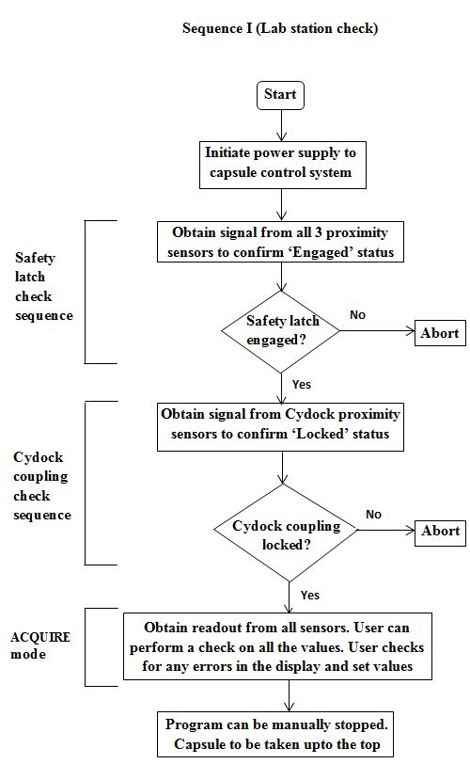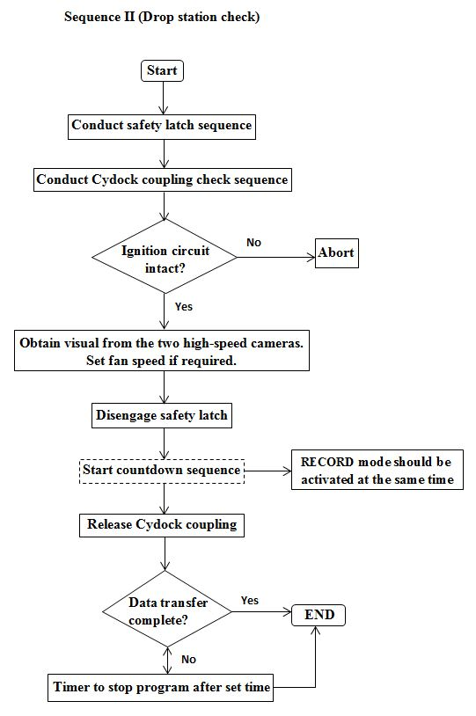
Figure 3: Flowchart depicting the sequence of operations and checks leading to the drop

Eligibility Criteria, General Terms and Conditions:

- The front end and other analysis software should be developed using 2015 version or above LabVIEW Software.
- The application software should be integrated with existing National Instruments make cRIO hardware available with IIT Madras.
- Existing application software developed using LabVIEW should be integrated with the new Application software. Application Source code should be supplied to purchaser for future up-gradation.
- Detailed System Requirement Specification (SRS) document should be prepared by the vendor in 3 weeks’ time after the release of the purchase order.
- Software should be developed by the vendor after the SRS document is approved by the user.
- Software should be designed by the certified LabVIEW architect and Software should be developed by Certified LabVIEW Developer. The bidder must have Certified LabVIEW Architects and Certified LabVIEW Developers as full time employees of the company. Certificate shall be enclosed at the time of submission of quote.
- The bidder must be an authorised system integrator for National Instruments and should have necessary technical expertise in development of similar integrated system using LabVIEW with cRIO real time controller and cRIO modules in the past. Authorization letter from National Instruments shall be enclosed at the time of submission of quote.
- Client list with full address including detail of contact person with phone no. email etc. to whom the similar software was supplied in the past 5 years should be provided by the vendor.
- Total demonstration of the supplied system should be done at purchaser site.
- Elaborate User manual for Hardware and Software shall be supplied in Soft Copy
- Bidder should be an ISO/CSIA certified company for atleast 2 years.
- Functionality Training shall be provided to 2 of the Purchaser engineers for application software. The basic stepwise instruction for changing the channels and configuring the cRIO should be included in the training.
- Issues related to integration of hardware and all categories of software bugs that may occur within a period of one year from the date of handover must be rectified free of cost.
- 10 Man-days shall be provided for modification of/addition to the delivered software, should the need arise.
- The bidder should attend the pre-bid meeting and also make a site visit to qualify for submitting the tender. Time and venue of meeting ( 10 AM, 23rd November 2017 at Aerospace Engineering Conference room)
- The project should be completed and delivered with necessary testing within a span of 9 – 12 weeks from the date of purchase order release. However, work on installing the trigger for the solenoid coils of the gate valve system and the pressure measurement of the airbag must commence immediately after the release of the purchase order.
- The tenderer shall meet the minimum technical specifications for the item that is being bid for. Any additional features in excess of those specifications will be appreciated. The additional features should be mentioned along with the technical description, wherever appropriate.

- Any instrument/sensor specification provided by the vendor has to be duly confirmed by either attaching a data sheet of the instrument to be procured or the concerned part number along with the make.

- The project will be considered complete only after the installation of hardware and software, both working together, completion of necessary testing and successful commissioning.

Contact person details for technical clarifications:
Dr. AMIT KUMAR
Contact No: 2257 4019
Email: amitk@iitm.ac.in

