Department of Aerospace Engineering
Indian Institute of Technology Madras
Chennai – 600 036, India
Dr. Ranjith Mohan
Project coordinator

Ref: No. ASE/RANT/VACUUM CHAMBER/ 2016/ DATE: 31/01/2017
To :

Due date :15/02/2017
Dear Sir,
- Quotations are invited in duplicate for the various items shown below/overleaf/enclosed list.
- The quotations duly sealed and super scribed on the envelope with reference no. and due date, should be addressed to the undersigned so as to reach him or before the due date stipulated above.
- Fax and Email quotation are not acceptable.
- Quotations should be valid for 60 days from the due date and period of delivery required, warranty terms etc. should also be clearly indicated. A minimum of one year warranty is required from the date of commissioning.
- Imported supplies should be quoted for CIF Madras.
- Local firms to quote for free delivery to this Institute. If quoted for Ex-Godown delivery charges be indicated separately.
- Relevant literature pertaining to the items quoted with full specifications (and drawing, if any) should be sent along with the Quotations, wherever applicable. Samples / machine/ equipment if called for should be submitted / demonstrated at free of charges, and collected back at the supplier’s expenses. Compliancy certificate is to be provided indicating conformity to the technical specifications
- Sales Tax/General Taxes/ED if applicable and such other taxes legally leviable and intended to be claimed should be distinctly shown along with the price quoted. If this is not indicated no such claim will be admitted at any stage. Thetaxes leviable should take into consideration that we are entitled to have concessional Sales Tax applicable to Non-Government Educational Institutions run with no profit motive for which a concession is given. Sales Tax Certificate will be issued at the time of final settlement of the bill.
- Goods should be supplied carriage paid and insured.
- Goods shall not be supplied without an official supply order.
- If the item is under DGS&D Rate contract No. and the price must be mentioned. It may also please be indicated whether the supply can be made direct to us at the Rate contract price (Please note that we are not Direct Demanding Officers). If so please send copy of the RC.
- The Guarantee period of the item may be indicated clearly.
- In case of LC. Payment, 90% of the payment will be made after completion of the supply. The balance 10% of the payment will be made after satisfactory installation of the equipment.
- IIT Madras is exempt from payment of Excise Duty and is eligible for concessional rate of custom duty. Necessary certificate will be issued on demand. IIT Madras will make necessary arrangements for the clearance of imported goods at the Airport/Seaport. Hence the price should not include the above charges.
- Acceptance and Rejection:- I.I.T. Madras has the right to accept the whole or any part of the Tender or portion of the quantity offered or reject it in full without assigning any reason.
Yours faithfully
- sd-
Project coordinator
Items required: VACUUM CHAMBERas per specifications enclosed.
-------------------------------------------------------------------------------------------------------------------
Phone Nos.: (044) 2257 50364026 /5000/ FAX: (044) 2257 4002, E-mail: ranjith.m@iitm.ac.in
31/01/2017
Specifications for Vacuum Chamber
We need a vacuum chamber with dimension 2.4mx2.4mx2.4m. The pressure (range: 1bar–0.006bar) inside the chamber should be read using a gauge fitted onto the chamber. In addition, a control panel should provide an automatic cutoff mechanism (for a set pressure) based on feedback from a pressure sensor. The chamber should have a door for entry of personnel and also a window to view. In addition, there should be provision for taking cables (signal/electrical).
Please provide quotations for the vacuum chamber as per the specifications mentioned below. Two possible designs are considered that differ only in thickness of plate used:
a) Thickness of plate is 12 mm b)Thickness of plate is 10 mm
Please provide two separate quotations for both the designs, that is, plate thickness 10mm and 12 mm (refer table 1 and table 2).
Line Diagram, Rendered views and specifications of chamber and door are given below:
Line Diagram
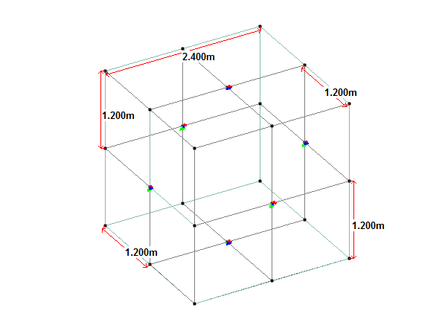
Fig:1 Line Diagram with Dimensions
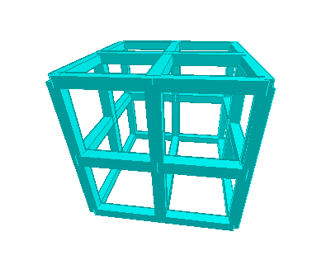
31/01/2017
Rendered Views

Fig:2 Rendered View
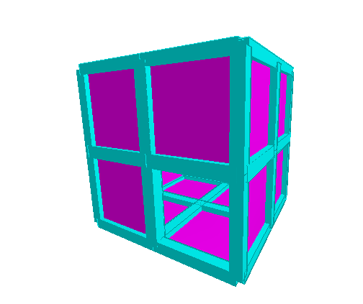
Fig:3 Rendered View
Door opening
(1m x 1 m)

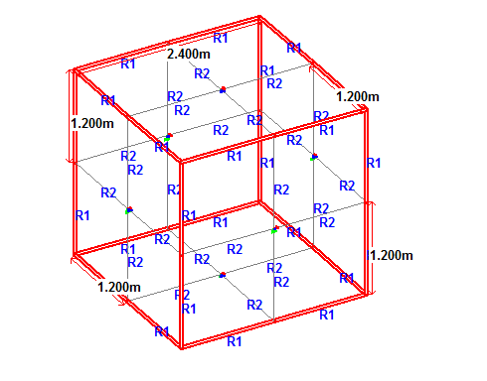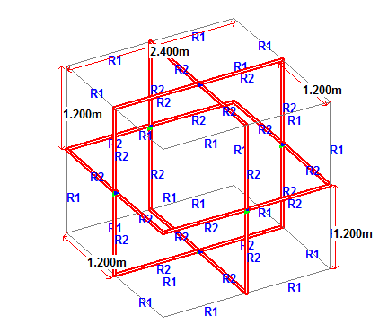
31/01/2017
180 mm X 180 mm – 8 mm thickness 180 mm X 180 mm – 8 mm thickness
Description
- Structure Dimension 2.4m X 2.4 m
- Loading- 1 bar- Vacuum pressure
- Member- TATA STRUCTURA (SHS)
- Plates- 12 mm thick / 10 mm thick (Mild Steel (Compatible with member))
Members- TATA Structura
- Outer frame members and Inner frame members: Square hollow section180 mm X 180 mm – 8 mm thickness
Other requirements
The vacuum pump available at aerospace department, IIT Madras has to be connected to the chamber. It may be assumed that the pump is about 3m away from where chamber will be installed. The chamber should have provision for two inlets that can be connected to vacuum pump. Also, one of the outlet or separate should provide for releasing air into the chamber to get it back to atmospheric pressure (after the experiments). The inside of the chamber should have a bottom plate to provide a uniform surface (to cover the members) and should be able to withstand the load due to personnel working inside the chamber. It may also be noted that, there should be:
- Airtight glands to tap power and signal wires.
- Provision for including pressure/vacuum gauge tapping (as well as vacuum gauge).
31/01/2017
Summary
Table 1 Vacuum Chamber with plate thickness 12mm
Vacuum Chamber Dimension | 2.4m x 2.4m x 2.4m
Member | TATA Structura (Steel Hollow Sections)
Dimension of member | Outer frame members and  Inner frame members: Square hollow section180 mm X 180 mm – 8 mm thickness
Plate Thickness | 12 mm
Material for Plate | Mild Steel (Compatible with member)
Required Vacuum level (Pump is available with IIT Madras) | ~1/100 atmosphere (~6 milli Bar)
Pressure control method | Using on off solenoid valve with less than 1-5%fluctuation in pressure level.  (If other methods are available kindly mention).
Instrumentation | Vacuum gauge, pressure sensors for operating solenoid valve
Temperature control | Not Required
Door specifications | Vacuum chamber Door  Size of door : 1000 x 1000 mm  Material : Mild steel
Window | Acrylic/Glass. On two sides of chamber.  Dimension:600 x 600 mm

31/01/2017

Table 2 Vacuum Chamber with plate thickness 10mm
Vacuum Chamber Dimension | 2.4m x 2.4m x 2.4m
Member | TATA Structura (Steel Hollow Sections)
Dimension of member | Outer frame members and  Inner frame members: Square hollow section180 mm X 180 mm – 8 mm thickness
Plate Thickness | 10 mm
Material for Plate | Mild Steel (Compatible with member)
Required Vacuum level (Pump is available with IIT Madras) | ~1/100 atmosphere (~6 milli Bar)
Pressure control method | Using on off solenoid valve with less than 1-5%fluctuation in pressure level.  (If other methods are available kindly mention).
Instrumentation | Vacuum gauge, pressure sensors for operating solenoid valve
Temperature control | Not Required
Door specifications | Vacuum chamber Door  Size of door : 1000 x 1000 mm  Material : Mild steel
Window | Acrylic/Glass. On two sides of chamber.  Dimension:600 x 600 mm

