**TUE-MSRC OFFICE FURNITURE SPECIFICATIONS:**

1. **CONFERENCE TABLE 8 SEATER: Quantity- 1 Nos.**

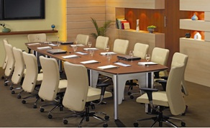

(I)WORK SURFACE:

Veneer -32mm Thick (±1mm)

Base Material ­ 18+12mm MDF boardNatural Veneer ­ 0.5mm on Top surface0.6mm balancing laminate on bottom surface

Chamfer edges ­ PU Matt painted. Veneer portion of work surface is finished in PU Matt paint.

(II). Veil and Cross Member

18mm Thick (±1mm)

Base material ­ 16mm Plain particle board

2mm Thk and 0.8mm Thk PVC edge banding of matching colour on outer edges of Veil

0.8mm Thk PVC edge banding of matching colour on outer edges of cross member

(III). Legs

Made from 1.6mm Matt silver Anodized Aluminium extrusion. Legs assembled together a plastic glide holder at bottom and 5mm thick MS powder coated sheet at top The Plastic glide holder is having provision for wire entry and glide fixing.

The wire carrying is facilited through the hollow space between two leg extrusions and the wires are concealed between removable rigid PVC extrusion in the leg.

(IV) Access Flap andSwitch Mounting Tray:

Made from Matt silver Anodized Aluminium extrusion and plastic moulded components to facilitate access of Electrical/Data/Voice sockets access from Top.Powder coated switch mounting tray made from 0.8mm and 1.2mm MS sheet. Switches tobe mounted on tray as per requirement provision for mounting 8­Module Anchor Roma switch plate on switch mounting tray.

**2. CONFERENCE CHAIR: Quantity- 8 NOS.**

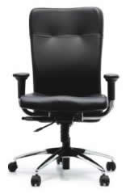

HIGH BACK CHAIR For Executive Cabin: KTS mechanism with Soft Touch Armrest. The seat is made up of 1.2 cm. thick hot pressed plywood upholstered with fabric andmoulded Polyurethane Foam. The back is made up 1.2 cm. thick hot pressed plywood upholstered with replaceable fabric upholstery covers and moulded polyurethane foam. The back ply and foam is designed with contoured lumber support for Comfortable seating posture.BACK SIZE : 48cm. (W) X 74.0cm. (H)BACK SIZE 48cm. (W) X 66.0cm. (H)SEAT SIZE: 50.0cm. (W) X 49.5cm. (H). The polyurethane foam for seat and back is moulded with density = 45 +/-2 kg/m3 and KNEE TILT SYNCHRO MECHANISM WITH SEAT DEPTH ADJUSTMENT MECHANISM: The mechanism is designed with the following features:360° revolving type.Single point control.Front pivot for tilt with feet resting on ground ensuring more comfort.Tilt tension adjustment.4-position locking with anti-shock feature Seat back tilting ratio of 1:2 (110 Seat Tilt /220 back tilt) Seat depth adjustment of 6cm can be locked in 6 positions. The backrest consists of a sliding up down mechanism, which can be adjusted in the range of 4.5 cm and can be locked in 4 positions for correct position of lumber support. The pneumatic height adjustment has an adjustment of 10.0 cm. The pedestal is fabricated from CR steel, chrome plated and assembled with injection moulded black polypropylene hub cap and 5 nos. twin wheel castors (castor wheel dia. 5.0 cm). The pedestal is 65.0cm. Pitch -center dia. (75.0 cm with castors). Leatherite Finish Upholstery with Chrome Finish Pedestal only

**3. LOW HEIGHT STORAGE UNIT: Quantity - 5 NOS.**

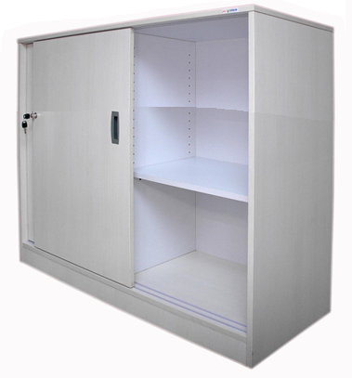

DIMENSION : 900mmW X450mmDX695mmHT

**BODY IS MADE FROM 18MM PLB WITH ALL THE EDGES SEALED WITH 0.8 MM** THICK PVC EDGEBAND. THE BACK PANEL IS 9MM WHITE PLT. THE ENTIRE CONSTRUCTION IS READY TO ASSEMBLE UNIT AND IS ASSEMBLED WITH SUITABLE KD FITTINGS.

THE SHELVES AND SEPARATOR PANELS ( IF AVAILABLE ) IS MADE FR OM 18 MM WHITE PLT AND EDGES ARE SEALED WITH 0.8 MM EDGE BAND. THE BOTTOM SHELF IS FIXED AND OTHER SHELVES HAVE ONE STEP ADJUSTMENT FOR OPTIMIZING THE SPACE.

**DOOR PANELS ARE MADE FROM 18 MM PLB WITH 2 MM EDGE BAND ON ALL** EDGES AD A FLUSH PLASTIC HANDLE IS FITTED VERTICALLY AT THE CENTRE OF THE DOOR. THE SDU RUNS IN A PVC TRACK MOUNTED ON THE TOP AND BOTTOM PANEL OF THE BODY.

SDU HAS A PUSH TYPE LOCK&ALL THE STORAGES ARE FITTED WITH A 6 MM LEVELER AT BOTTOM FOR LEVELING.

1. **GLASS DOOR STORAGE UNIT: Quantity – 18 Nos.**

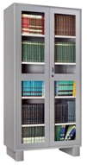

DIMENSION: 916mmW X486mm DX1980mm ht

Construction : Welded Construction , 0.7mm thick CRCA for shelf , 0.8mm CRCA for back, o.8mm thick high yield CRCA for door. 0.9mm thick CRCA for all other components, CRCA ‘D’ as per IS:513. With Glass Door.

Locking and Handle : Brass Handle , Two way locking mechanism with shooting bolt.

Shelving : Height wise adjustable shelf mounting. Uniform distributed load capacity as per full shelf is 40kg maximum. 40 nos of adjustable full shelf.

Lever : M10 screw type lever with hex plastic base.

Finish : MS powder coated finish thickness of 50 Micron

**5.RECEPTION SOFA SET : 1 set ( 3 seater – 1Nos, 2 seater-2 Nos and Single seater- 1 Nos.)**

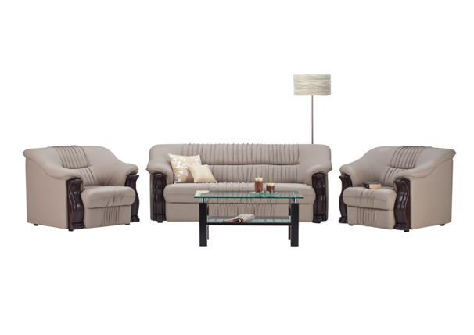

1 SEATER-1000WX 880 D X 780Ht.

2 SEATER-1375WX 880 D X 780Ht

3 SEATER-2000WX 880 D X 780Ht

Upholstery :PVC in SynLth sofa

Frame Material : Tropical Wood

Foam :Slab stock foam of density 32 kg/cubic m at seat and 28 kg/cubic m at back.

Wooden facia : MDF

Webbing : Nylon

1. **MEETING ROOM / STAFF TABLE : 8 Nos.**

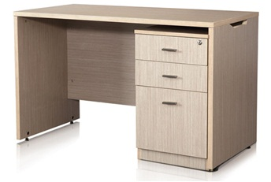

Table of size 1200mm x 600mm x 740mm having having wood laminate finish the table top / work surface: Made from 25mm thick PLB with PVC lipping. Side panels: Made from 18mm thick PLT with PVC lipping. Modesty Panel: Made from 18mm thick PLT with PVC lipping. Neat wiring flow with cut-outs on both sides. freestanding pedestal for adequate personal storage.

**7. HIGH BACK CHAIR – FACULTY: 4 Nos.**

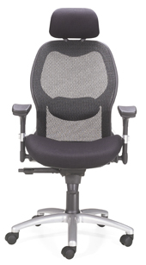

(I) SEAT/BACK ASSEMBLY: The seat is made up of insert mouldedPolyurethane Foam upholstered with foam laminated mesh fabric. The insert moulded foam is assembled over a load bearing plastic seat cover. The back is made up of two piece injection moulded frame. Theinner frame is upholstered with mesh fabric and mounted on the mainassembly. The back has adjustable lumbar support for achieving comfortable seating posture.Sub Assembly Seat size = 52.5 cm Width, 51 cm Depth. With Head rest.

Sub Assembly Back size= 48.5 cm Max Width, 62 cm Ht.Effective Back Ht from Seat = 57 cm

(I) POLYURETHANE FOAM: The polyurethane foam for seat ismoulded with density = 75 ±4 kg/m3 and Hardness = 34 ± 4.

(III) ARMRESTS (ADJUSTABLE) : The armrest top is injection mouldedin polyurethane and mounted on the injection moulded heightadjustable type armrest. The armrest height is adjustable up to 4.5cm

in 3 steps & width adjustable. ArmTop Out to Out Dim = 62 to 65 cm,ArmTop Centre to Centre Dim = 53 to 56 cm

(IV) FRONT PIVOT SYNCHRO MECHANISM: The mechanism is designed with the following features:3600 revolving type - Single point control - Front pivot for tilt with feetresting on round g ensuring more comfort - Tilt tension adjustment -3position locking with antismoke feature

(V) CONNECTING SPINE BRACKET: spine bracket is made ofAluminumdie cast piece connecting back with mechanism.

(VI) PNEUMATIC HEIGHT ADJUSTMENT: The pneumatic heightadjustment has an adjustment of 8.5 cm.(VII) PEDESTAL ASSEMBLY: Pedestal is made of Die cast Aluminumfitted with 5 nos. twin wheel castors (castor wheel dia. 6.0 cm). The pedestal is 65.0cm. Pitch center dia. (71.0 cm with castors).

(VIII) TWIN WHEEL CASTORS: The twin wheel castors are injection molded in Nylon.

**8.FACULTY VISITOR CHAIR : 8 Nos.**

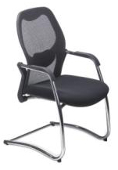

(I) SEAT/BACK ASSEMBLY: The seat is made up of insert moulded Polyurethane Foam upholstered with foam laminated mesh fabric. The insert moulded foam is assembled over a load bearing plastic seat cover. The back is made up of two piece injection moulded frame. The inner frame is upholstered with mesh fabric and mounted on the main assembly. The back has adjustable lumbar support for achieving comfortable seating posture. Sub Assembly Seat size = 52.5 cm Width, 51 cm Depth.

Sub Assembly Back size= 48.5 cm Max Width, 62 cm Ht. Effective Back Ht from Seat = 57 cm

(II) POLYURETHANE FOAM: The polyurethane foam for seat is moulded with density = 75 ±4 kg/m3 and Hardness = 34 ± 4.

(III). Leg : The sled base leg frame welded assembly is made from MS ERW round table with base plate for seat fixing.

**9. FACULTY TABLE : Quantity - 4 Nos.**

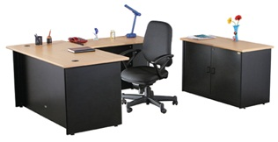

Main Table of size 1500 x 750 x 740 mm(wxdxh) having top and side panel 25mm thick plain particleboard(PPB) clad with 0.6 mm thick post formed laminate and 1mmthick backing laminate (BDL). Flat edge duly sealed with 2mm thickPVC beading and modesty panel of 18mm thick plain article

board(PPB) clad with 1.0mm thick decorative laminate(DL) on bothsides. Edge sealed with 2mm thick PVC beading .

**10. STAFF CHAIR / STUDENT CHAIR: Quantity - 17 Nos.**

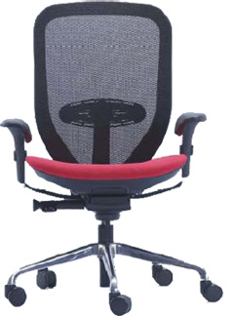

SEAT &ASSMBLY: Cushioned seat assembly consists of seat outer & upholstered seat inner with moulded PU foam & Fabric. Net back is made of back outer & back inner and upholstered using polyester mesh fabric with high tenstile strength. Full back size -46.5cm W X 60. Cm Ht , Seat Size -51cm W X49cm Ht.Seat Depth adjustment.

POLYURETHANE FOAM: The polyurethane foam for seat is moulded with density = 45 ±2 kg/m3 and Hardness = 12 ± 2.

Arm rest : Two adjustments – Height & depth.

Mechanism: Active Bio Synchro mechanism

The mechanism is designed with the following features:360degree revolving type , Front PivotTilt tension adjustment -5 position tilt limiter. Seat back tilting ratio 1:2.

Pedestal is made of Die cast Aluminum fitted with 5 nos. twin wheel castors (castor wheel dia. 6.0 cm). The pedestal is 65.0cm. Pitch center dia. (71.0 cm with castors).

**11. UPS /SERVER ROOM CHAIR: Quantity- 4 Nos.**

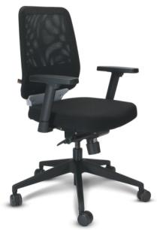

(I) SEAT/BACK ASSEMBLY: The seat is made up of Hot pressed plywood and upholstered with fabric and moulded PU Foam.

Size – 76.1 cm W X 76.1cm X96.3 cm X SH 45.2cm – 55.2cm

(II) FRONT PIVOT SYNCHRO MECHANISM: The mechanism is designed with the following features:3600 revolving type - Single point control - Front pivot for tilt with feet resting on round g ensuring more comfort - Tilt tension adjustment -4 position locking with antismoke feature .

Pedestal is made of Die cast Aluminum fitted with 5 nos. twin wheel castors (castor wheel dia. 6.0 cm). The pedestal is 65.0cm. Pitch center dia. (71.0 cm with castors).

**12.MEETING ROOM CHAIR : Quantity – 35 Nos.**

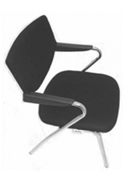

Seat is made up of Plywood and upholstered with foam and fabric . The back is injection moulded and upholstered with foam and fabric.

Back – 48cm W X 32.5 Cm H

Seat – 45.5 cm W X 48.5cm D

Tubular frame is made up of 2.2 ±0.03cm X 0.16 ±0.0128cm thk tube chrome plated and fitted with moulded armrest.

|  |  |  |
| --- | --- | --- |
|  | **13. PANTRY FURNITURE SET - SPECIFICATIONS AND BOQ** |  |
| Sl. No. | Description | Qty |
| 1 | Thali kit (Drawer + Cutlery Tray + Cup & Saucer 100 mm + Thali Bskt 150 mm) 600 mm | 1 |
|  |  |  |
| 2 | Utensil kit - set of 2 plain baskets 600 mm | 1 |
|  |  |  |
| 3 | Alluminium Glass door shutters with soft closing hinges 450 mm wide | 5 |
|  |  |  |
| 4 | Back panel common for main counter and TOP units 450 mm | 2 |
|  |  |  |
| 5 | Back panel common for main counter and TOP units 600 mm | 3 |
|  |  |  |
| 6 | Back panel common for main counter and TOP units 900 mm | 2 |
|  |  |  |
| 7 | Bottom /shelf main floor unit 450 mm | 1 |
|  |  |  |
| 8 | Bottom /shelf main floor unit 600 mm | 5 |
|  |  |  |
| 9 | Bottom panel TOP units: RAL white 450 mm | 1 |
|  |  |  |
| 10 | Bottom panel TOP units: RAL white 900 mm | 2 |
|  |  |  |
| 11 | Common frame - Main Floor Units | 1 |
|  |  |  |
| 12 | Common frame - TOP Units | 2 |
|  |  |  |
| 13 | False Side Panel - Main Floor Units | 8 |
|  |  |  |
| 14 | Horizontal stiffner for floor unit main and counter 450mm | 4 |
|  |  |  |
| 15 | Horizontal stiffner for floor unit main and counter 600 mm | 12 |
|  |  |  |
| 16 | MARINE PLY side panel tall, tall pull & appliance unit | 1 |
|  |  |  |
| 17 | Shelf TOP units 450 mm | 1 |
|  |  |  |
| 18 | Shelf TOP units 900 mm | 2 |
|  |  |  |
| 19 | Top panel for TOP units(set of top panel with horizontal stiffener) 450 mm | 1 |
|  |  |  |
| 20 | Top panel for TOP units(set of top panel with horizontal stiffener) 900 mm | 2 |
|  |  |  |
| 21 | BRUSHED ALUM. SKIRTING 100mm HARDWARE PACKET FOR KITCHEN CABINETS | 1 |
|  |  |  |
| 22 | Handle Arc 128 mm pitch | 22 |
|  |  |  |
| 23 | Hardware for Pelmet | 1 |
|  |  |  |
| 24 | Hardware packet for Kitchen | 2 |
|  |  |  |
| 25 | Hinges (95 degree opening) | 16 |
|  |  |  |
| 26 | Legs 100 mm | 18 |
|  |  |  |
| 27 | Set of Ball Slides 530 mm Long Full Extn. | 9 |
|  |  |  |
| 28 | Shelf Supports | 16 |
|  |  |  |
| 29 | SKIRTING (REHAU) SYSTEM-100mm BRUSHED ALUMINIUM | 4 |
|  |  |  |
| 30 | Appliance Unit Carcass with Shelves( w/o side panels): RAL white | 1 |
|  |  |  |
| 31 | Multi-utility kit - set of 4 drawers RAL white | 1 |
|  |  |  |
| 32 | 300 mm wide Hinged MARINE SHUTTER | 4 |
|  |  |  |
| 33 | 300 mm wide x 348 mm (H) Hinged MARINE SHUTTER | 2 |
|  |  |  |
| 34 | 300 mm wide x 523 mm (H) Hinged MARINE SHUTTER | 2 |
|  |  |  |
| 35 | Cornice in 2200mm length in grey colour MARINE PLY | 3 |
|  |  |  |
| 36 | MPLY 175H450W DRW FRN | 4 |
|  |  |  |
| 37 | MPLY 175H600W DRW FRN | 2 |
|  |  |  |
| 38 | MPLY 350H600W DRW FRN | 3 |
|  |  |  |
| 39 | Pelmet in 2200 mm length in grey colour MARINE PLY | 2 |
|  |  |  |
| 40 | Wooden End Panels Floor Main | 6 |
|  |  |  |
| 41 | Wooden End Side Panel top Unit | 2 |

**14.Head Room – Pantry Table : Quantity: 2 Nos.**

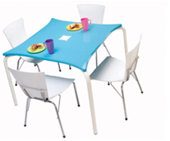

Dimention : 1135 W x 1175 B x 750Ht mm

Work Surface: PU painted 25 mm thick base material 25mm mdf board on top PU painting of minimum 2h hardness with 75% glass specially profiled edge for comfort.

Understructure : bend pipe under structure of MS powder coated pipe dia 38mm 2mm thick.

**15. Head Room Pantry Chairs : Quantity: 8 Nos.**



500D X 500W X 810H X430 Seat Height. MS powder coated Legs and back with Arm rest.

**16. Coffee Table: Quantity: 2 Nos.**

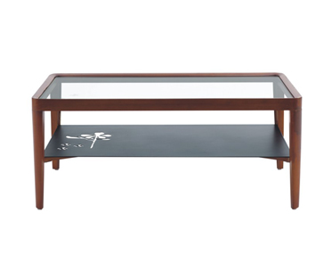

1000mm W X 600mmD X 428 Ht

Rubber wood frame with glass top and tapered legs.

The storage is made of powder coated MS sheet with laser cut floral pattern inscribed on it.

**17.Corner Table : Quantity: 2 Nos.**

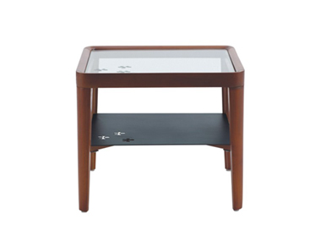

500mm W X 500mmD X 428 Ht

Rubber wood frame with glass top and tapered legs.

The storage is made of powder coated MS sheet with laser cut floral pattern inscribed on it.