Hkkjrh; izkS|ksfxdhlaLFkkuenzklpsUuS 600 036
INDIAN INSTITUTE OF TECHNOLOGY MADRAS Chennai 600 036
HkaMkj ,oa Ø; vuqHkkx
STORES & PURCHASE SECTION
Email: adstores@iitm.ac.in
nwjHkk"k% ¼044½ 2257 8285@8287@8290 QSDl% ¼044½ 2257 8292
Telephone : (044) 2257 8285/8287/8290 FAX: (044) 2257 8292
GSTIN: 33AAAAI3615G1Z6
SHEBA SABARI P.K.
Assistant Registrar (Stores & Purchase) Date: 16.01.2024

Tender No: SPS/Disposal of waste/2023-24/22/SPL Due Date: 05.02.2024 Before 2.00 p.m.

Dear Sir/Madam,

On behalf of the Indian Institute of Technology Madras, Tenders are invited in two bid system namely technical and financial for
Ceiling rate contract for sale and disposal of solid waste from IITM Campus on “AS IS WHERE IS BASIS”

Conforming to the specifications enclosed.

Tender Documents may be downloaded from Central Public Procurement Portal https://etenders.gov.in/eprocure/app. Aspiring Bidders who have not enrolled / registered in e-procurement should enroll / register before participating through the website https://etenders.gov.in/eprocure/app. The portal enrolment is free of cost. Bidders are advised to go through instructions provided at “Help for contractors”. [Special Instructions to the Contractors/Bidders for the e-submission of the bids online through this eProcurement Portal”].

Bidders can access tender documents on the website (For searching in the NIC site, kindly go to Tender Search option and type ‘IIT’. Thereafter, Click on “GO” button to view all IIT Madras tenders). Select the appropriate tender and fill them with all relevant information and submit the completed tender document online on the website https://etenders.gov.in/eprocure/appas per the schedule attached.

No manual bids will be accepted. All tender documents including Pre-qualification (Technical) and Financial bids should be submitted in the E-procurement portal.
1 | LAST DATE for receipt of Tender |  | : | 05.02.2024 before 02.00 p.m
 | Date & Time of opening of Tender |  | : | 06.02.2024@ 03.00 p.m
 | Inspection |  | : | The interested bidder may visit/inspect yard in IITM campus for assessing the waste @ 11.00 AM on 22.01.2024. The site inspection is to get a general idea on the type of solid waste and segregation in IIT Madras campus.
 | Pre-bid meeting |  | : | 22.01.2024@ 12.30 PM 2nd Floor, Conference Room, Admin Block
GUIDELINES FOR TENDER SUBMISSION IN CENTRAL PUBLIC PROCUREMENT PORTAL
(E-PROCUREMENT MODE)
 | Submission of Tender |  | : | As per the directives of Department of Expenditure, this tender document has been published on the Central Public Procurement Portal  URL: https://etenders.gov.in/eprocure/app  The bidders are required to submit soft copies of their bids electronically on the CPP Portal, using valid Digital Signature Certificates. The instructions given below are meant to assist the bidders in registering on the CPP Portal, prepare their bids in accordance with the requirements and submitting their bids online on the CPP Portal.  More information useful for submitting online bids on the CPP Portal may be obtained at: https://etenders.gov.in/eprocure/app .  All tender documents including pre-qualification bid, Technical Bid & Financial Bid should be submitted separately in online CPP portal as per the specified format only. Right is reserved to ignore any tender which fails to comply with the above instructions. No manual bid submission will be entertained
B | Instructions for online bid submission |  | : | REGISTRATION  - Bidders are required to enrol on the e-Procurement module of the Central Public Procurement Portal URL: https://etenders.gov.in/eprocure/app by clicking on “Online Bidder Enrollment”. Enrolment on the CPP Portal is free of charge.  - As part of the enrolment process, the bidders will be required to choose a unique username and assign a password for their accounts.  - Bidders are advised to register their valid email address and mobile numbers as part of the registration process. These would be used for any communication from the CPP Portal.  - Upon enrolment, the bidders will be required to register their valid Digital Signature Certificate (Class II or Class III Certificates with signing key usage) issued by any Certifying Authority recognized by CCA India (e.g. Sify / TCS / nCode / eMudhra etc.) https://etenders.gov.in/eprocure/app?component=%24DirectLink&page=DSCInfo&service=direct&session=T with their profile.  - Only one valid DSC should be registered by a bidder. Please note that the bidders are responsible to ensure that they do not lend their DSCs to others which may lead to misuse.  - Bidder then may log in to the site through the secured log-in by entering their user ID / password and the password of the DSC / eToken.
C |  | Searching for tender documents | : | - There are various search options built in the CPP Portal, to facilitate bidders to search active tenders by several parameters. These parameters could include Tender ID, organization name, location, date, value, etc. There is also an option of advanced search for tenders, wherein the bidders may combine a number of search parameters such as organization name, form of contract, location, date, other keywords etc. to search for a tender published on the CPP Portal.  - Once the bidders have selected the tenders they are interested in, they may download the required documents / tender schedules. These tenders can be moved to the respective “My Tender” folder. This would enable the CPP Portal to intimate the bidders through SMS / email in case there is any corrigendum issued to the tender document.  - The bidder should make a note of the unique Tender ID assigned to each tender, in case they want to obtain any clarification / help from the Helpdesk.
D |  | Preparation of bids | : | - Bidders should take into account any corrigendum published on the tender document before submitting their bids.  - Please go through the tender advertisement and the tender document carefully to understand the documents required to be submitted as part of the bid. Please note the number of covers in which the bid documents have to be submitted, the number of documents including the names and content of each of the documents that needs to be submitted. Any deviations from these may lead to rejection of the bid.  - Bidder, in advance, should prepare the bid documents to be submitted as indicated in the tender document / schedule and generally shall be in PDF / XLS formats as the case may be. Bid documents may be scanned with 100 dpi with black and white option.  - To avoid the time and effort required in uploading the same set of standard documents which are required to be submitted as a part of every bid, a provision of uploading such standard documents (e.g. PAN card copy, GSTIN Details, annual reports, auditor certificates etc.) has been provided to the bidders. Bidders can use the “My Documents” area available to them to upload such documents. These documents may be directly submitted from the “My Documents” area while submitting a bid, and need not be uploaded again and again. This will lead to a reduction in the time required for the bid submission process.
E |  | Submission of bids | : | - Bidders should log into the site well in advance for bid submission so that he/she can upload the bid in time i.e. on or before the bid submission date and time. Bidders will be responsible for any delay due to other issues.  - The bidder has to digitally sign and upload the required bid documents one by one as indicated in the tender document.  - Bidder has to transfer the EMD as applicable by online mode only. The EMD should be transferred on or before 05.02.2024 before 02.00 p.m. If the EMD is not transferred before the closure date and time, the tender will be summarily rejected. The proof of transfer has to be submitted in the Technical Bid. Otherwise, the tender will be summarily rejected.  - A standard BOQ format has been provided with the tender document to be filled by all the bidders. Bidders are requested to note that they should necessarily submit their financial bids in the format provided and no other format is acceptable. Bidders are required to download the BOQ file, open it and complete the details with their respective financial quotes and other details (such as name of the bidder). If the BOQ file is found to be modified by the bidder, the bid will be rejected.  - The server time (which is displayed on the bidders’ dashboard) will be considered as the standard time for referencing the deadlines for submission of the bids by the bidders, opening of bids etc. The bidders should follow this time during bid submission.  - The Tender Inviting Authority (TIA) will not be held responsible for any sort of delay or the difficulties faced during the submission of bids online by the bidders due to local issues.  - The uploaded tender documents become readable only after the tender opening by the authorized bid openers.  - Upon the successful and timely submission of bids, the portal will give a successful bid submission message & a bid summary will be displayed with the bid no. and the date & time of submission of the bid with all other relevant details.  - Kindly add scanned PDF of all relevant documents in a single PDF file of compliance sheet.
F |  | Assistance to bidders | : | - Any queries relating to the tender document and the terms and conditions contained therein should be addressed to the Tender Inviting Authority for a tender or the relevant contact person indicated in the tender.  - Any queries relating to the process of online bid submission or queries relating to CPP Portal in general may be directed to the 24x7 CPP Portal Helpdesk. The contact number for the helpdesk is [0120-4200462, 0120-4001002, 0120-4001005]
G |  | General Instructions to the Bidders | : | - The tenders will be received online through portal https://etenders.gov.in/eprocure/app. In the Technical Bids, the bidders are required to upload all the documents in pdf format.  - Possession of a Valid Class II/III Digital Signature Certificate (DSC) in the form of smart card/e-token in the company's name is a prerequisite for registration and participating in the bid submission activities through https://etenders.gov.in/eprocure/app  - Digital Signature Certificates can be obtained from the authorized certifying agencies, details of which are available in the web site https://etenders.gov.in/eprocure/appunder the “Information about DSC
H |  | Earnest Money Deposit (EMD) | : | i. EMD of INR 30,000 (Rupees Thirty thousand only) should be transferred through NEFT/RTGS to the following bank account on or before due date 05.02.2024 before 2:00 p.m.  Name : Registrar IIT Madras  Bank : State Bank of India  Account No. : 10620824305  Branch : IIT MADRAS  IFSC CODE : SBIN0001055  ii. As per O.M. No.F.1/2/2022-PPD Dated 01.04.2022, the EMD will be returned to the unsuccessful Bidder(s), within 30 days after declaration of result of first stage i.e. technical evaluation etc. The EMD shall be forfeited if any Bidder withdraws the offer before finalization of the tender. The EMD amount should not be sent through Demand Draft. The EMD will not carry any interest.  iii. Non-submission of EMD details on or before the due date and time will result in rejection of the e-bid.  iv. As per Rule 170 of GFR 2017, exemption of EMD will be given to the firm seeking such exemption. Copies of relevant orders/ documents regarding such exemption should be submitted along with the tender document.  v. In case of a successful bidder, the EMD will be adjusted towards the Performance Security on request. The amount of EMD is liable to be forfeited, if the bidder withdraws from the offer after submission of the tender or after the acceptance of the offer and fails to remit the Performance Security.
I |  | Marking on Technical Bid | : | - The scope of work for this tender is given in Annexure A. The Bidders shall go through the pre-qualification criteria and submit the technical bid in the proforma given in Annexure B in the tender document along with the supporting documents.  - The Technical bid should be submitted in pdf format only through online (e-tender). No manual submission of bids will be entertained.  - The technical bid should have the page-wise heading as “Technical Bid” and page no. in all pages with seal and signature of authorized signatory. The total no. of pages should be mentioned at the last page of the documents.  - The technical bid should consist of  - Document proof for EMD payment  - Technical Compliance sheet as per proforma given in Annexure-B along with Proof
J |  | Marking on Financial Bid | : | Financial bid should be submitted in the prescribed proforma format given in Annexure-C as per BOQ in .xls format through e-tender only. No manual or other form of submission of Financial Bid will be entertained.
2 |  | Preparation of Tender:  - The bidders are advised to inspect and examine the solid waste and satisfy the requirements before submitting the bid.  - The rate quoted shall be all inclusive and no extra payment will be made other than statutory revisions as per the terms and conditions stipulated in this contract document.  - The offer/bids should be submitted through online only in TWO bid system i.e. Technical Bid and Financial Bid separately.  - The bidder has to submit the tender document duly signed on all pages by an authorized person and his / her full name and status be indicated below the signature along with official stamp of the firm. Submission of wrong / forged information / document will be liable to legal action, and rejection of tender submitted by the firm.  - The tenders of the contracting agency/firm/company not in possession of valid statutory license/ registrations are liable for rejections.  - If any relative of the bidder is an employee of the IIT Madras, the name, designation and relationship of such employee shall be intimated to the Registrar, IIT Madras in writing while submitting the tender.  - No bidder will be allowed to withdraw / alter / modify after submission of tenders within the bid validity period.
3 |  | Signing of Tender:  The Tender is liable to be rejected if complete information is not given therein or if the particulars and date (if any) asked for in the schedule to the Tender are not fully filled in or not duly signed/authenticated. Specific attention is drawn to the delivery dates and terms and conditions enclosed herewith. Each page of the bids required to be signed and bears the official seal of the Bidders.  If the application is made by a firm in partnership, it shall be signed (with seal) by all the partners of the firm above their full typewritten names and current addresses or alternatively by a partner holding power of attorney for the firm in which case a certified copy of the power of attorney shall accompany the application. A certified copy of the partnership deed along with current addresses of all the partners of the firm shall also accompany the application.  If a limited company or a corporation makes the application, it shall be signed by a duly authorized person holding power of attorney for signing the application, in which case a certified copy of the power of attorney shall accompany the application. Such limited company or corporation may be required to furnish satisfactory evidence of its existence. The applicant shall also furnish a copy of the Memorandum of Articles of association duly attested by a Notary Public.
4 |  | Period for which the offer will remain open:  The bids shall remain valid for acceptance/validity till: 120 days from the date of opening of the tender. However, the day up to which the offer is to remain open is declared a closed holiday for the Indian Institute of Technology Madras, the offer shall remain open for acceptance till the next working day.
5 |  | Prices:  - Inclusive of transport, lifting, labour, materials, consumables, safety PPEs, tools and plants etc as mentioned in the tender conditions. The prices quoted by the Bidders should be Exclusive of GST and other statutory levies. GST shall be paid by the contractor to IITM as per the prevailing rate of tax on the day of disposal of the solid waste.  - All conditional tenders will be summarily rejected.
6 |  | Payment: The vendor shall clean the solid waste material every month (OR) when the shed is half filled (OR) as and when instructed by the Engineering in-charge and payment as per the percentage quoted to be made to IITM within 2 days before lifting the materials. The GST shall be paid extra by contractor at the prevailing rate on the date of disposal.
7 |  | Terms and Conditions: Failure to comply with any of the instructions stated in this document or offering unsatisfactory explanations for non-compliance will likely lead to rejection of offers.
8 |  | Right of Acceptance: IIT Madras reserves the right to reject the whole or any part of the Tender without assigning any reason or to accept them in part or full.
9 |  | Communication of Acceptance: Letter of Intimation and acceptance will be communicated by post to the successful bidder to the address indicated in the bid.
10 |  | Duration of the contract: The contract will be awarded for a period up to 31st March 2024 and may be further extended up to a maximum of one year from the initial date of issue of work order depending on the satisfactory performance and as recommended by the Contract Monitoring Committee.
11 |  | All information including selection and rejection of technical or financial bids of the prospective bidders will be communicated through e-Tender portal. In terms of Rule 173(iv) of General Financial Rule 2017, the bidder shall be at liberty to question the bidding conditions, bidding process and/or rejection of bids.
12 |  | Conditions of contract:  Bidders should quote on the basis of the conditions referred to in the invitation to tender and tender papers.
13 |  | Bidder shall submit along with this Tender:  - Name and full address of the Banker, Swift code, PAN and GSTIN number.  - GST registration proof showing registration number, area of registration etc.
14 |  | Jurisdiction: All questions, disputes, or differences arising under, out of or in connection with the contract, if concluded, shall be subject to the exclusive jurisdiction at the place from which the acceptance of Tender is issued.
15 |  | Dispute Settlement:  - It is mutually agreed that all differences and disputes arising out of or in connection with these agreements shall be settled by mutual discussions and negotiations. If such disputes and differences are not settled within 15 days from the date of written request made by the contractor to the agreement signing authority, the contractor can make a written request to the Dispute Resolution Committee (DRC) / (i.e Contract Monitoring Committee) within 7 days for further resolution. The DRC shall make a resolution within 14 days from the date of receipt of request made by the contractor. If the contractor is not satisfied with the resolution made by the DRC, the contractor shall make a request to the Director, IIT Madras within 7 days from the date of DRC's resolution for appointing a sole Arbitrator. The sole Arbitrator's decision on the issue shall be final and binding on both the parties.  - It is also agreed that in case of any disagreements/disputes in connection with the contract, the same shall be settled under the Court of Law within its jurisdiction at Chennai. The resultant contract will be interpreted under Indian Laws.
16 |  | Breach of Terms and Conditions:  IITM may, without prejudice to any other remedy for breach of contract by written notice of default sent to the bidder, terminate the contract in whole or part:  - If the bidder fails to provide any or all of the services within the period(s) specified in the contract.  - If the bidder fails to perform any other obligation(s) under the contract.  If the bidder has engaged in corrupt or fraudulent or unethical practices in competing for or in executing the contract.
17 |  | PENALTY:  In case the solid waste is not lifted within the specified time, a ground rent per day will be charged @ 0.5 percent of the sale value for 7 days. After one week notice period, it will be treated as abandoned solid waste lot and appropriate action will be initiated against the contractor for such abandoned lot apart from forfeiture of Security Deposit and debarring/blacklisting for two years from any auctions / tenders in IIT Madras.
18 |  | The bidder shall certify that the tender document submitted by him / her are of the same replica of the tender document as published by IIT Madras and no corrections, additions and alterations made to the same. If any deviation found in the same at any stage and date, the bid / contract will be rejected / terminated and actions will be initiated as per the terms and conditions of the contract.
19 |  | BIDDER ELIGIBILITY CRITERIA:  - The bidder shall not be from a country sharing land border with India and if the bidder is from a country sharing land border with India the bidder should have been registered with the competent authority as per orders of DIPP OM No. F. No. 6/18/2019-PPD dated 23rd July 2020, and MoCI Order No. P-45021/112/2020-PP (BE II) (E-43780) dated 24th August 2020. A declaration as per format given in Annexure – D shall be submitted with the bid.  - Only 'Class-I local suppliers' and ‘Class-II local suppliers’, as defined under DIPP, MoCI Order No. P45021/2/2017-PP (BE II) dated 16th September 2020 and other subsequent orders issued therein, shall be eligible to bid in this tender. Declaration for Class-I / Class-II local suppliers should be submitted in the prescribed proforma format as per Annexure – E.  - The bidder nor any of its partners has been blacklisted / debarred /involved / convicted in any criminal case / economic offence nor any criminal case / economic offence is pending against the firm or any partner of the Firm before any Court of Law / Police. A self-declaration format given in Annexure – F.  - The bidder should have experience in disposal of solid waste and handled atleast one contract to Central/ State Government/ Corporations/Autonomous Institution/ reputed private firms/ Institutions etc. for the last three years i.e. 2020-21, 2021-22 and 2022-23.Copies of the documents listed below should be submitted as proof for the above Work Experience:  1) Work Order  2) Work Completion Certificates or Performance Certificate issued by the client  - The bidder should have filed Income Tax returns for the past 3 years. The annual account statement and Profit & Loss statement for the FY 2020-21, 2021-22, 2022-23 should be attached.  - The agency should have an average annual turnover of minimum Rs.5.00 Lakhs for the last 3 years FY 2020-21, 2021-22, 2022-23. This should be certified by a chartered accountant. (Necessary Annual accounts statements should be attached).
20 |  | Number of Bids and their Submission  The bidders should submit the bids in two bid system as detailed below:-  Bid I Technical Bid  The technical bid should consist of Proof of EMD, Bidder Eligibility Criteria, Compliance sheet (Proforma given in Annexure-B) along with all relevant documents proof.  The bidder should go through the scope of work given in Annexure-A of the tender document, understand the requirement of IITM and submit their technical bid covering the following details along with all relevant document proof in the proforma given in Annexure–B  The proof attached should be indexed and page numbers of the attached proof should be clearly mentioned in the Technical Bid format. Any tender document without these details shall be considered invalid and rejected.  Bid II Financial Bid  The financial bid should be submitted in excel format (BoQ) as per the Proforma (Annexure-C) uploaded in CPP e-procurement portal. The rate should be quoted above the rates mentioned in the Appendix “D” in a single percentage (%) plus only and should be exclusive of GST but inclusive of all other statutory levies including labour, material, safety PPEs, consumables, transportation and local body approval if any etc.
21 |  | Evaluation of Bids:  Bid evaluation will be done in two stages:  A. Technical Bid Evaluation:  Bidder who have complied all the conditions in the Bidder Eligibility Criteria alone will be considered for the opening of Financial Bid.  B. Financial Bid Evaluation  - The technically qualified bidder who has quoted for the solid waste above the reserve price on Single highest percentage (only plus %) for overall items listed in “Appendix D” will be declared as successful bidder (H1) and the contract will be awarded to the successful bidder (H1) subject to other usual conditions.  - In case of tie among the bidders in the financial bid evaluation, those bidders alone will be asked to resubmit the financial bids as a tie breaker.  - In the event of tie in the resubmitted financial bids, the bidder who has the highest annual turnover will be selected as success bidder.  - Negative quote will not be considered for financial evaluation.
22 |  | Selection of successful bidder and Award of Work  The work will be awarded to the Highest Percentage quoted bidder.
23 |  | The bidder shall certify that the tender documents submitted by him / her are of the same replica of the tender document as published by IIT Madras and no corrections, additions and alterations made to the same. If any deviation is found in the same at any stage and date, the bid / contract will be rejected / terminated and actions will be initiated as per the terms and conditions of the contract.
24 |  | It is an e-tender and hence the opening of the bids may be checked by using the respective logins of the bidders.
25 |  | Execution of Contract and Security Deposit  - A formal agreement shall be entered into with a successful bidder.  - Declaration of Non-Black listing to be executed & attested by Public Notary / Executive Magistrate on Rs.100/- stamp paper by successful bidder as per Annexure – G.  - The successful bidder shall submit a Performance Security amount of Rs.1,00,000/- (Rupees One lakh only) in favour of “The Registrar, IIT Madras” within 15 (fifteen) days from the date of issue of Order by IIT Madras, which shall be released on expiry/termination of the contract after adjustment of dues, if any.  The performance Security deposit will be liable to be forfeited or appropriated in the event of unsatisfactory performance of the contract and loss or damage, if any, sustained by the Institute on account of failure or negligence on the part of employees of the contractor.
26 |  | Bidders can submit their queries and doubts to the email id: adstores@iitm.ac.in on or before 22.01.2024 @12.30 PM. Clarification to the queries and doubts raised by the bidders will be issued as a corrigendum/addendum in the e-tenders portal and Institute Website (tenders.iitm.ac.in). For the bidders, submitting bids on downloaded tender documents, it is ‘bidders’ responsibility to check for any amendment/corrigendum on the website of IIT Madras or check for the same CPP Portal before submitting their duly completed bids. After the pre-bid meeting, queries/ clarification if any will not be considered.
Sd/-
Assistant Registrar
(Stores & Purchase Section)

ACKNOWLEDGEMENT

It is hereby acknowledged that I/We have gone through all the points listed under “Specification, Guidelines, Terms and Conditions and Scope of Work of tender document, the same is abided and agreed to be executed. In case, if the above information is found false, I/We are fully aware that the tender /order will be rejected / cancelled by IIT Madras.

Signature of the bidder
Name & Address of the bidder with Office Stamp

SCHEDULE OF TENDER

Name of Organization | Indian Institute of Technology Madras
Tender Type (Open/Limited/EOI/Auction/Single) | OPEN
Tender Category (Services/Goods/Works) | Services
Type/Form of Contract (Work/Supply/Auction/ Service/ Buy/ Empanelment/ Sell) | Services
Product Category (Civil Works/Electrical Works/Fleet Management/ Computer Systems) | Ceiling Rate contract for sale and disposal of solid waste in IITM Campus on “AS IS WHERE IS BASIS”
Source of Fund (Institute/Project) | IIT Madras (Institute)
Is Multi Currency Allowed | No
Date of Issue/Publishing | 16.01.2024
Document Download Start Date | 16.01.2024
Document Download End Date | 05.02.2024
Pre-bid Meeting | 22.01.2024@ 12.30 PM 2nd Floor, Conference Room, Admin Block
Bid Submission Start Date | 29.01.2024
Last Date and Time for Uploading of Bids | 05.02.2024 at 02.00 PM
Date and Time of Tender Opening | 06.02.2024 at 03.00 PM
EMD | Rs.30,000/-
No. of Covers (1/2/3/4) | 2
Bid Validity days (180/120/90/60/30) | 120 Days
Address for Communication | The Assistant Registrar  Stores & Purchase Section  IIT Madras  Chennai – 600 036
Contact No. | For Queries : 044- 2257 8287/8285/8288/8290
Email Address | adstores@iitm.ac.in

ANNEXURE – A
Scope of Work
Ceiling rate contract for sale and disposal of solid waste from IITM Campus on “AS IS WHERE IS BASIS”
Tender No. SPS/Disposal of waste/2023-24/22/SPL

- The reference images of waste items are in Appendix-C.
- The waste material in Sl. No 1-18 is always segregated.
- The vendor shall remove /lift the waste materials by every month or when the shed is half filled or as and when instructed by the Engineering In charge at the percentage rate quoted.
- The performance of the contract will be evaluated by the Contract Monitoring Committee of the institute.
- The Contract Monitoring Committee shall also act as Dispute Resolution Committee.
- The Bid will not be accepted without Declaration as per Appendix-A.
- Upon written request from the contractor, the rate for any new/additional items shall be fixed and approved by the Contract Monitoring Committee based on the prevailing market rate.
- The disposal of solid waste have to be done only on working days (between 09.00 AM to 5.00PM) within stipulated period as per contract and with valid Gate pass issued by Engineering Unit of IIT Madras. If the solid waste material is not removed with in specified time, it will be treated as abandoned lot and appropriate action will be initiated against the defaulter for such abandoned lot apart from forfeiture of Performance Security Deposit and debarring/blacklisting for two years from IIT Madras auctions/tenders.
- IIT Madras reserves the right to recall the tender or resale the abandoned solid waste material by the H1, to H2 & H3 bidder subject to acceptance of H1 percentage rate. The default bidder will not have any claim whatsoever reason about the abandoned lot.
- Disposal activity should not be initiated without an official work order issued by IIT Madras.
- The weight of loaded and empty weight of the truck shall be measured at Institute Weighbridge or Institute weighing machine at the place of storage yard at IIT Madras. The weight shall be witnessed by the contractor and officials nominated by Engineering Unit-IIT Madras.
- The personnel employed for the disposal activity (job) shall strictly obey the Safety Rules in force while working in IIT Madras.
- The successful bidder should bring their own vehicle, equipment, tools, safety equipment/gears/PPEs, manpower and any other materials required to remove the disposal lot safely without onsite segregation at IIT Madras Campus. No picking or choosing will be allowed in the disposal site/Institute premises by the bidders.
- Loading, Transportation and Unloading will be the responsibility of the successful tenderer at their own cost.
- The disposal lot shall be carried only in the licensed trucks and the driver of the vehicle should have valid driving license.
- The Loading should be done only in the supervision of designated officer(s) of this office and security personnel.
- The loaded vehicle will be accompanied by the IIT Madras security personnel up to the exit gate.
- No other material should be removed from the site, apart from the tendered solid waste and as informed by the IIT Madras officials.
- The successful bidder should make sure that no scrap items of the tendered lot are left behind in any part of the building/premises and get the acknowledgement from the official nominated by IIT Madras as per Appendix-B.
- The lifting of material shall be done without damaging the premises etc. The bidder is liable for the damages, losses, etc., in the event of any occurrence.
- If the bidder fails to complete the work or any portion thereof as agreed upon or refuses to comply with any directions given to him, IITM shall initiate action as per rules.
- IITM will not be responsible for any loss/injury suffered by the bidder or employed personnel for whatsoever reason.
- IIT Madras, Chennai also reserves the right to accept / reject the offers or cancel the whole tender proceedings without assigning any reason whatsoever. The decision of IIT Madras will be final and binding on the bidder(s). Bidders are not entitled to claim any damage or compensation in case of such cancellation.
- The successful bidder should follow appropriate guidelines of the local authority to dispose the items outside the campus and IIT Madras will not take any responsibility for any violence of the bidder in this regard.
- The Model Calculation for the payment by vendor is given in Appendix-E for reference purpose only.

ANNEXURE: B
PROFORMA FOR TECHNICAL BID
Ceiling rate contract for sale and disposal of solid waste from IITM Campus on “AS IS WHERE IS BASIS”
Tender No. SPS/Disposal of waste/2023-24/22/SPL

1 | Name of the Firm:
 | Complete Address:
 | Phone No. |  | E-mail ID:
2 | Contact Person / Representative Name and Designation:
 | Phone |  | Mobile Phone:
3 | License No (if any): |  | Company Registration No.:
 | (Enclose proof for handling waste)
6 | Bank Details - Bank Name, A/c No., IFSC and Complete Address
7 | Any other information in support of the credentials |  | Details , if any, to be furnished

BIDDER ELIGIBILITY CRITERIA:
Sl.No | BIDDER ELIGIBILITY CRITERIA | Compliance (Yes/No) | Reference Page No. | Remarks, If any
1 | The bidder shall not be from a country sharing land border with India and if the bidder is from a country sharing land border with India the bidder should have been registered with the competent authority as per orders of DIPP OM No. F. No. 6/18/2019-PPD dated 23rd July 2020, and MoCI Order No. P-45021/112/2020-PP (BE II) (E-43780) dated 24th August 2020. A declaration as per format given in Annexure – D shall be submitted with the bid.
2 | Only 'Class-I local suppliers' and ‘Class-II local suppliers’, as defined under DIPP, MoCI Order No. P45021/2/2017-PP (BE II) dated 16th September 2020 and other subsequent orders issued therein, shall be eligible to bid in this tender. Declaration for Class-I / Class-II local suppliers should be submitted in the prescribed proforma format as per Annexure –E.
3 | The bidder nor any of its partners has been blacklisted / debarred /involved / convicted in any criminal case / economic offence nor any criminal case / economic offence is pending against the firm or any partner of the Firm before any Court of Law / Police. A self-declaration format given in Annexure – F.
4 | The bidder should have experience in disposal of solid waste and handled atleast one contract to Central/ State Government/ Corporations/Autonomous Institution/ reputed private firms/ Institutions etc. for the last three years i.e. 2020-21, 2021-22 and 2022-23.Copies of the documents listed below should be submitted as proof for the above Work Experience:  1) Work Order  2) Work Completion Certificates or Performance Certificate issued by the client
5 | The bidder should have filed Income Tax returns for the past 3 years. The annual account statement and Profit & Loss statement for the FY 2020-21, 2021-22, 2022-23 should be attached.
6 | The agency should have an average annual turnover of minimum Rs.5.0 Lakhs during the last 3 years FY 2020-21, 2021-22, 2022-23. This should be certified by a Chartered Accountant. (Necessary Annual accounts statements should be attached).

SIGNATURE OF BIDDER ALONG WITH
SEAL OF THE COMPANY WITH DATE
ANNEXURE -C
FINANCIAL BID (PROFORMA) - BILL OF QUANTITIES (BOQ)
Ceiling rate contract for sale and disposal of solid waste from IITM Campus on “AS IS WHERE IS BASIS”
Tender No. SPS/Disposal of waste/2023-24/22/SPL
PROFORMA FOR PRICE BID
SI.No | Description of Work | Unit | Reserve Price fixed by IITM | Prevailing GST for the items | Single highest percentage for overall items to be quoted by the bidder (Only plus %)
 |  |  | Rs.
 | Ceiling rate contract for sale and disposal of solid waste from IITM Campus on “AS IS WHERE IS BASIS” for the following items: (payment to be made by the contractor to IIT Madras) |  |  |  | ENTER AND SUBMIT THE FINANCIAL BID IN CPP PORTAL
1 | Paper high quality (card board, white paper) | Kg | 18
2 | Paper moderate quality (note book, colour book, colour record, ice cup, etc.) | Kg | 15
3 | Steel (not attracted by magnet) : Beer tin, utensils, etc., | Kg | 45
4 | Steel/ Iron (attracted by magnet): Iron furniture, rod, furniture, sheet, powder metals. | Kg | 24
5 | Plastic (K.D): (Biscuit cover, Tetra pack, packing brown paper cover, paper bundle cover etc.) | Kg | 10
6 | Plastic (high quality): (Toys, oil cans, pipes, drum, hose, PVC, furniture). | Kg | 15
7 | Plastic (medium quality): (Milk cover, thick plastic bags, Milk cover, oil cover, etc., | Kg | 6
8 | Plastic (Low Quality): Plastic baas- (black/white) | Kg | 1.5
9 | Plastic pet bottle | Kg | 10
10 | Aluminium (metal wire) | Kg | 100
11 | Aluminium Crack/ foil) | Kg | 25
12 | Glass bottles (liquor bottle, oil bottle, perfume bottle) | Kg | 2
13 | Coconut shell | Kg | 4
14 | Broken furniture (Cushion sofa, revolving chair, wooden normal chaff) | Each | 3
15 | Wooden packing materials | Kg | 2
16 | Thermocol (Polystyrene board) | Kg | 2.5
17 | Copper (Wire/ utensils) | Kg | 620
18 | Stainless steel ( Pipe /Plate) | Kg | 50
 | In addition to the performance security deposit, the contractor shall make an advance deposit of Rs. 3.00 Lakhs to IIT Madras before commencement of disposal activity. This advance payment will be adjusted against the actual payment to be made by the contractor to IIT Madras. As and when required and as intimated by the IIT Madras, the contractor shall recoup the advance payment not less than Rs 3.00 lakhs to IIT Madras. The actual payment to be made by the contractor to IIT Madras shall be calculated by multiplying the actual quantity of each items as weighed in IIT Madras weighbridge and the base rate as published by IIT Madras (Appendix D) including the plus percentage quoted by the contractor
 | Overall percentage of the rate quoted for the sale and disposal of waste (Quoted percentage should be in plus percentage only)
Note: Inclusive of transport, lifting, labour, materials, consumables, safety PPEs, tools and plants etc as mentioned in the tender conditions. The prices quoted by the Bidders should be Exclusive of GST but including other statutory levies and fees to be paid to local body if any.
Signature of the authorized person with Seal of the offer.

ANNEXURE-D

(To be given on the letter head of the bidder)

No. Dated:

CERTIFICATE

I have read the clause regarding restrictions on procurement from a bidder of a country which shares a land border with India and hereby certify that I am not from such a country.

OR (whichever is applicable)

I have read the clause regarding restrictions on procurement from a bidder of a country which shares a land border with India and hereby certify that I from _______________ (Name of Country) and has been registered with the Competent Authority. I also certify that I fulfill all the requirements in this regard and is eligible to be considered.

(Copy/ evidence of valid registration by the Competent Authority is to be attached)

Place: Signature of the Bidder
Date: Name & Address of the
Bidder with Office Stamp

ANNEXURE – E

FORMAT FOR AFFIDAVIT OF SELF-CERTIFICATION UNDER PUBLIC PROCUREMENT POLICY
(PREFERENCE TO MAKE IN INDIA) 2017
Tender Reference Number: SPS/Disposal of waste/2023-24/22/SPL
Ceiling rate contract for sale and disposal of solid waste from IITM Campus on “AS IS WHERE IS BASIS”

Date: __________

I/We ____________________________________________S/o, D/o, W/o, ____________________________________
Resident of _______________________________________________________________________________________
hereby solemnly affirm and declare as under:

That I will agree to abide by the terms and conditions of the Public Procurement (Preference to Make in India) Policy vide GoI Order no. P-45021/2/2017-PP (B.E.-II) dated 15.06.2017 (subsequently revised vide orders dated 28.05.2018, 29.05.2019and 04.06.2020)MOCI order No. 45021/2/2017-PP (BE II) Dt.16th September 2020 & P- 45021/102/2019-BE-II-Part(1) (E-50310) Dt.4th March 2021 and any subsequent modifications/Amendments, if any and

That the local content for all inputs which constitute the said item/service/work has been verified by me and I am responsible for the correctness of the claims made therein.

Tick ( ) and Fill the Appropriate Category
I/We [name of the supplier] hereby confirm in respect of quoted items that Local Content is equal to or more than 50% and come under “Class-I Local Supplier” category.
I/We [name of the supplier] hereby confirm in respect of quoted items that Local Content is equal to or more than 20% but less than 50% and come under “Class-II Local Supplier” category.

The details of the location (s) at which the local value addition is made and the proportionate value of local content in percentage

Percentage of Local content : _________ %**

Location at which value addition done : ____________________________________________________
____________________________________________________
____________________________________________________

For and on behalf of (Name of firm/entity)

Authorized signatory (To be duly authorized by the Board of Directors)
<Insert Name, Designation and Contact No.>

[Note: In case of procurement for a value in excess of Rs. 10 Crores, the bidders shall provide this certificate from statutory auditor or cost auditor of the company (in the case of companies) or from a practicing cost accountant or practicing chartered accountant (in respect of suppliers other than companies) giving the percentage of local content.]

This letter should be on the letterhead of the quoting firm and should be signed by a competent authority.
** Services such as transportation, insurance, installation, commissioning, and training and after sales service support like AMC/CMC cannot be claimed as local value addition

ANNEXURE - F
(To be given on the letter head of the bidder)
Self-Declaration that the Service Provider has not been Black listed

I …………………………………………………………………………………………………………. S/o ……………………….………………………………
R/o ……………………………. police station ………………. District …………………………. ……………………………………….. Director
/ partner/ sole proprietor (Strike out whichever is not applicable) of ………………………………………………………..………
……………………………………….. (Firm or Company) do hereby declare and solemnly affirm:

  - That the Firm ………………………………………………….……………… ……………………. has not been Blacklisted or declared insolvent by any of the Union or State Government / Organization.
  - That none of the individual / firm / Company Blacklisted or any partners or shareholder thereof has any connection directly or indirectly with or has any subsistence interest in the deponent business / firm company.
  - That neither the Firm nor any of its partner has been involved / convicted in any criminal case / economic offence nor any criminal case / economic offence is pending against the firm or any partner of the Firm before any Court of Law / Police.

Place:

Date:

SIGNATURE OF BIDDER ALONG WITH
SEAL OF THE COMPANY WITH DATE

ANNEXURE-G

(To be executed & Attested by Public Notary / Executive Magistrate on Rs.100/- Stamp paper by the successful bidder)
DECLARATION REGARDING BLACKLISTING / DEBARRING FROM TAKING PART IN GOVT. TENDER
BY IIT MADRAS / GOVT. DEPT.

I / We Proprietor / Partner (s) Director (s) of M/s. _________________________ hereby declare that the firm / company name M/s. _______________________________________ has not been blacklisted or debarred in the past by IIT Madras or any other Government organization from taking part in Government tenders.

Or

I / We Proprietor / Partner (s) Director (s) of M/s. _________________________ hereby declare that the firm / company name M/s. _________________________________________ was blacklisted or debarred in the past by IIT Madras Government organization from taking part in Government tenders for a period of _________________________years w.e.f_________

The period is over on _______________ and now the firm / company is entitled to take in Government tenders.

In case, if the above information is found false, I / We are fully aware that the render / contract will be rejected / cancelled by IIT Madras and shall be forfeited.

In addition to the above, IIT Madras will not be responsible to pay the bills for any partially completed work.

Signature: ___________________________
Name: ______________________________
Capacity in which as signed: _____________
Name & Address of the firm: _________________________
_________________________
_________________________

Place: Seal of the firm should be affixed

APPENDIX-A
Declaration

I /We have understood all the terms and conditions contained in IIT Madras E-auction notice and General terms and conditions for forward auction of GeM for the Ceiling rate contract for sale and disposal of solid waste from IITM Campus on “AS IS WHERE IS BASIS” vide Reference No. SPS/Disposal of waste /2023-24/22/SPL and in case the bid is accepted, we shall abide by the terms and conditions of the tender document without any further cause or reason. I am also aware that I should not segregate the disposal waste in the IITM Premises. I assure for safe disposal of the waste at my site as per the appropriate guidelines of the local authority. IITM will not be responsible for any violations of disposal activities by me outside the IITM campus.

Firm’s Name:
Contact Person Name:
Mobile No:
GST No:
Address:

Signature of the bidder with Seal.

APPENDIX-B

Acknowledgement

We certify that M/s. ……………………………………………… cleared the all the condemned items as per the Tender Reference No. SPS/Disposal of waste/2023-24/22/SPL and Work order No:
…………………………………………

Signature of the end user

Name of the Bidder:
Signature:
Date:

APPENDIX-C

Reference Images of scrap and solid waste material in IIT Madras
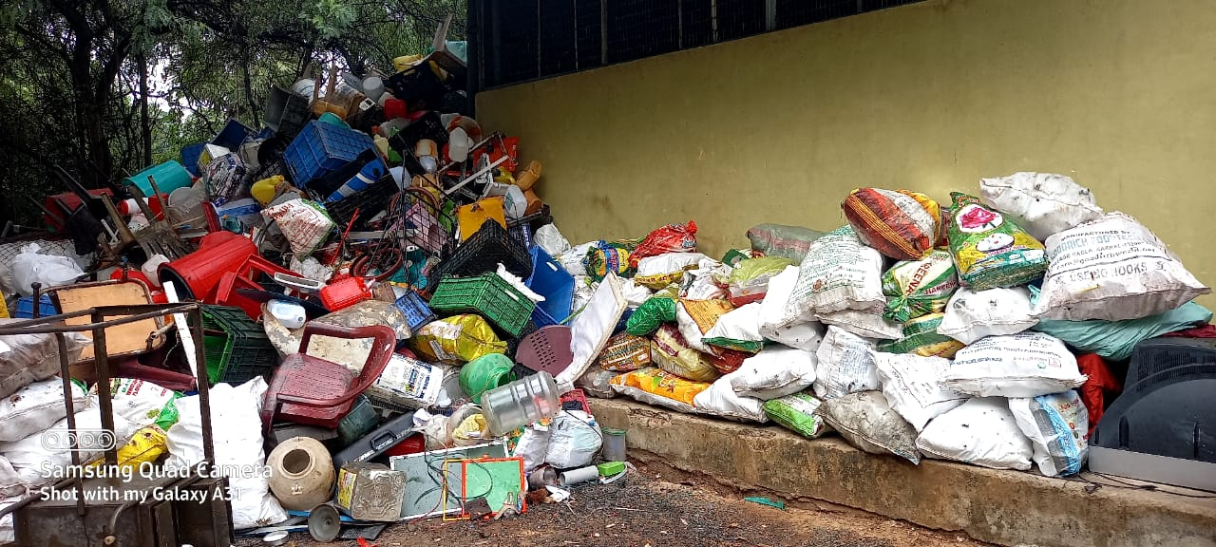
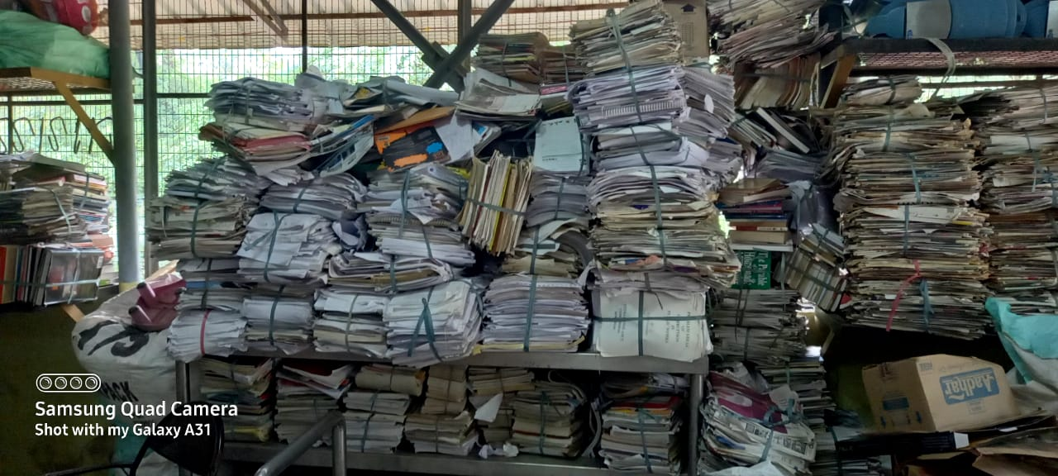
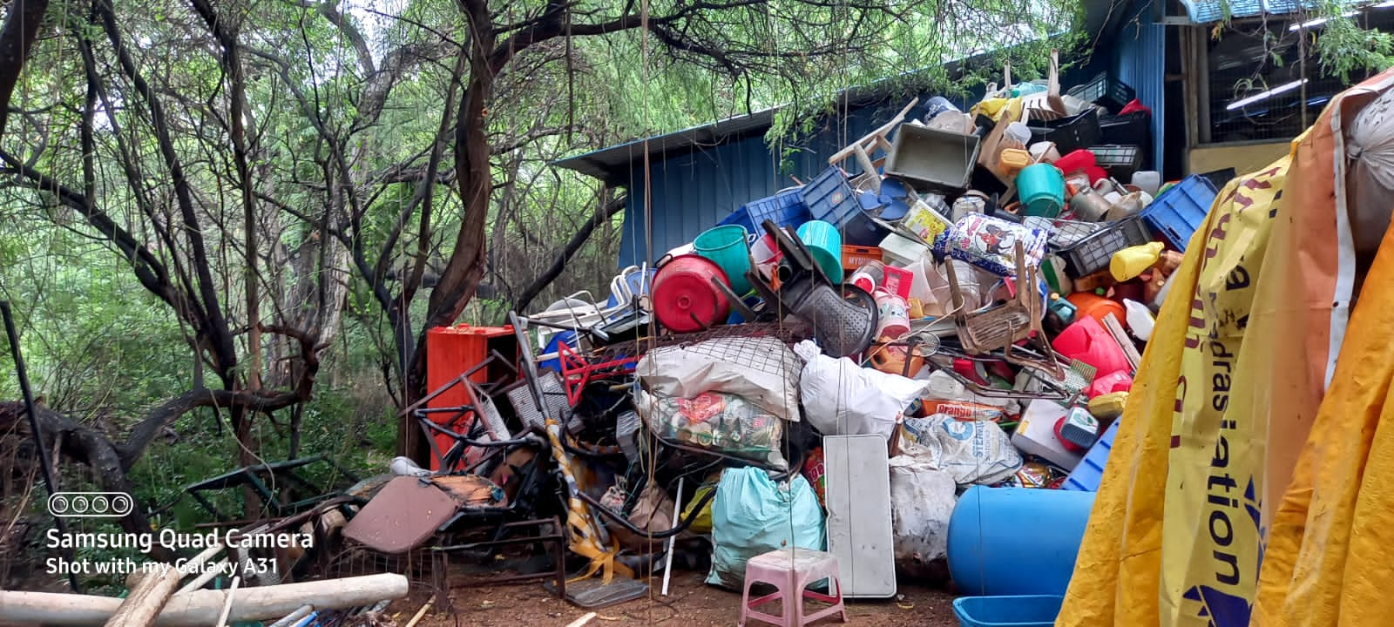

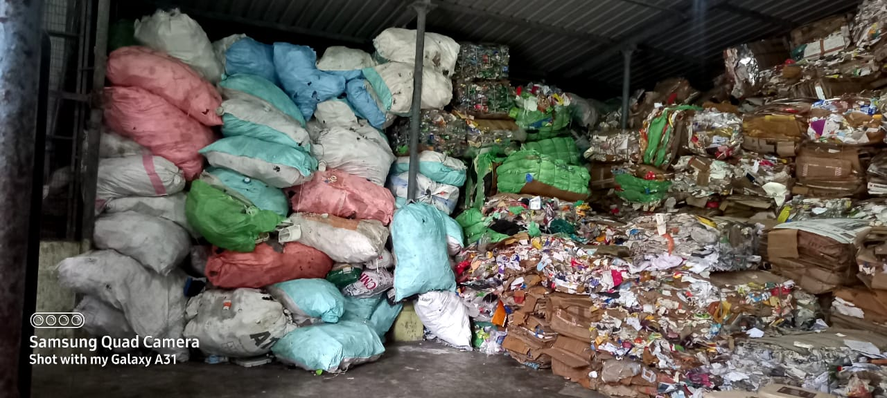
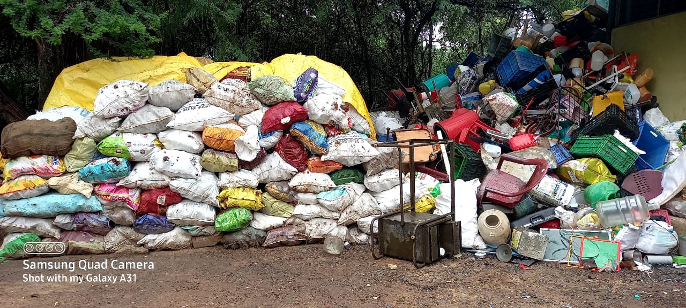
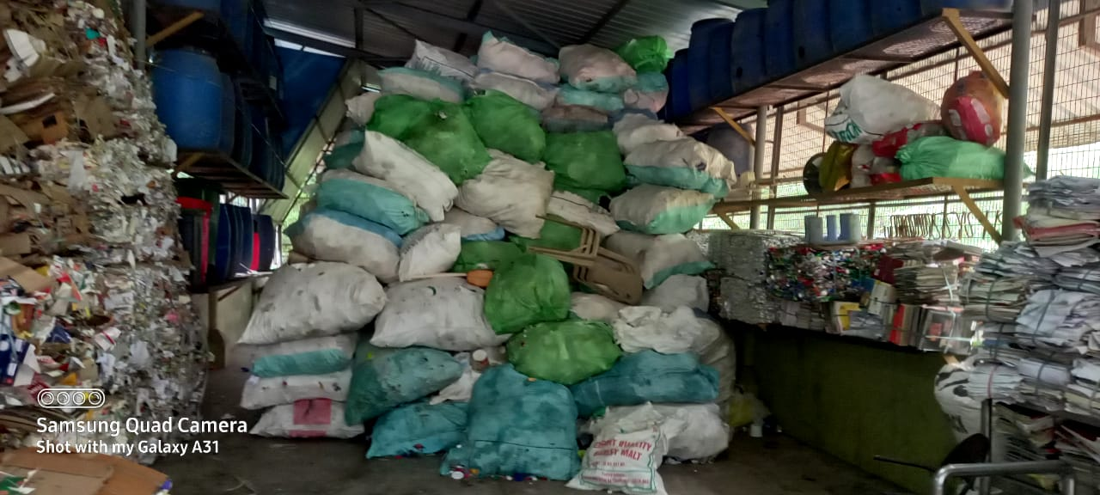

APPENDIX-D
SOLID WASTE ITEMS AVAILABLE IN IIT MADRAS CAMPUS ON “AS IS WHERE BASIS IS”
S.No | Scrap/waste item | Unit | Reserve price fixed by IIT Madras in  (Rs)
1 | Paper high Quality (card board, white paper) | Kg | 18
2 | Paper moderate quality (note book, Colour book, colour record, ice cups) | Kg | 15
3 | Steel (Not attracted by magnet): Beer tin, utensils etc | Kg | 45
4 | Steel/Iron (attracted by magnet): Iron Furniture rod, Furniture, Sheet, powder, metals | Kg | 24
5 | Plastic (K.D): biscuit cover, Tetra pack, packing brown paper cover, paper bundle cover etc. | Kg | 10
6 | Plastic (high quality): toys, oil cans, pipes, drum, hose, PVC, furniture | Kg | 15
7 | Plastic (Medium Quality): Milk cover, thick plastic bags, Milk cover, Oil cover, etc. | Kg | 6
8 | Plastic (Low quality): Plastic bags (Black/White) | Kg | 1.5
9 | Plastic pet bottle | Kg | 10
10 | Aluminium (metal, wire) | Kg | 100
11 | Aluminium (rack/foil) | Kg | 25
12 | Glass bottles (liquor bottle, oil bottle, perfume bottle) | Kg | 2
13 | Coconut shell | Kg | 4
14 | Broken furniture (Cushion sofa, revolving chair, wooden normal chair) | Each | 3
15 | Wooden packing materials | Kg | 2
16 | Thermocol (polystyrene board) | Kg | 2.5
17 | Copper (Wire/utensils) | Kg | 620
18 | Stainless steel (Pipe/Plate) | Kg | 50
For additional / new items other than the above items if any, upon request from the contractor, the contract monitoring committee will examine the request of the contractor and approve the rate for additional / new items based on the prevailing market rate.
Assistant Registrar (S&P)

APPENDIX-E
MODEL CALCULATION FOR THE PAYMENT BY VENDOR
FINANCIAL BID (PROFORMA) - BILL OF QUANTITIES (BOQ)
Ceiling rate contract for sale and disposal of solid waste from IITM Campus on “AS IS WHERE IS BASIS”
Tender No. SPS/Disposal of waste/2023-24/22/SPL
PROFORMA FOR PRICE BID
SI.No | Description of Work | Unit | Reserve Price fixed by IITM | Single highest percentage for overall items to be quoted by the bidder (Only plus %)  (b) | Reserve Price + percentage quoted by the bidder  Model | Prevailing GST for the items | Rate to be paid by the vendor in Rs | Total Amount to be paid by the bidder
 |  |  | Rs.  (a) |  | c= (a*b)+ a | (d) | e= [(c*d)+c] | f = e* Qty
 | Ceiling rate contract for sale and disposal of solid waste from IITM Campus on “AS IS WHERE IS BASIS” for the following items: (payment to be made by the contractor to IIT Madras) |  |  | *To be filled by the bidder |  | *To be filled by the bidder |  | *For example if the quantity of each item is 100kg
1 | Paper high quality (card board, white paper) | Kg | 18 | 5% | 18.9 | 5% | 19.845 | 1984.5
3 | Steel (not attracted by magnet) : Beer tin, utensils, etc., | Kg | 45 |  | 47.25 | 18% | 55.755 | 5575.5
5 | Plastic (K.D): (Biscuit cover, Tetra pack, packing brown paper cover, paper bundle cover etc.) | Kg | 10 |  | 10.5 | 18% | 12.39 | 1239
 | Overall percentage of the rate quoted for the sale and disposal of waste (Quoted percentage should be in plus percentage only) |  |  | 5%

Note: Inclusive of transport, lifting, labour, materials, consumables, safety PPEs, tools and plants etc as mentioned in the tender conditions. The prices quoted by the Bidders should be Exclusive of GST but including other statutory levies and fees to be paid to local body if any.

Signature of the authorized person with Seal of the offer.

